****-



NAME: ____________________

FORM: 8___



**EX**

**am**

**perience8**

**Week Beginning 29th April, 2019**

Your Essential Guide to Exams in Year 8

**Welcome to your Bridgewater Year 8 Exams Experience (BEE8)**

We understand that most people do not really like having to sit exams, but they are an important part of the education system.

BEE8 aims to prepare you as well as possible for the important exams you will sit when you are older. We want you to know how to revise effectively and how to manage your anxieties. Yes, it is important to do as well as possible in all of your exams, but first and foremost, BEE8 is about managing the process of sitting exams and reflecting on your marks.

Within this booklet, you will find general revision tips, subject-specific exam preparation pointers as well as space for you to reflect on your performance. When your exams are over and your teachers have marked them, you will find space to write down your marks as well as What Went Well (WWW) in each exam as well as targets for improvement or Even Better If (EBI). Time will be built into lessons for you to complete these sections and to reflect on your over-all experience of the exams.

On the back of this booklet is a blank timetable for you to write down when you will sit each exam. Your teachers will tell you when these will be.

**Showcase your Talents.**

They say ‘no one likes a show-off’, but when it comes to exams, that is exactly what we want you to do. Show us what you know and what you have learned. As part of ‘S for Success,’ we call this skill of showing off ‘Showcase’. The ability to present and justify your own ideas is a skill that employers will value in later life. Showcasing your talents is what exams are all about, too.

**Top Exam Tip for Showcasing:**

Make the most of your knowledge. If you have gone to the trouble of learning facts, make sure you explain them properly and in enough detail!



**Exam Room Rules**

You will probably sit your exams in your usual classroom but you must remember that this is a formal (serious) occasion and your teacher may have a different seating plan for the exam. Some of you may sit your exam in an Access Room if, for example, you are entitled to additional time or the help of a reader. The access rooms for the week will be as follows:

|  |  |  |  |  |
| --- | --- | --- | --- | --- |
| Mon : tbc | Tuesday : tbc | Wed : tbc | Thu : tbc | Fri : tbc |

Wherever you sit your exam, remember the following important rules:

1. Make sure you have a pen that works (as well as a spare in case your pen runs out!)
2. Enter the classroom in silence and sit where you are told
3. Remain silent before, during and after the examination until your teacher has collected in your exam paper and told you that you can talk.
4. Make sure you write your name on any pieces of paper that you use
5. Do not attempt to communicate with anybody else during the exam, including lip-reading and any other signs.
6. Mobile phones should be switched off and must remain in your bag or pocket, completely out of sight.

**Some Tips for Successful Revision**

1. Start revising early i.e. weeks, not hours before the exam. Make a timetable to plan your revision and stick to it.
2. Mind maps are a visual way of showing your ideas. The best mind maps make use of pictures, colours, key words and different styles of lines to show the connections between points. Mind maps start from a central theme (this might be your topic title or question) and then expand as you start to explore your key points.

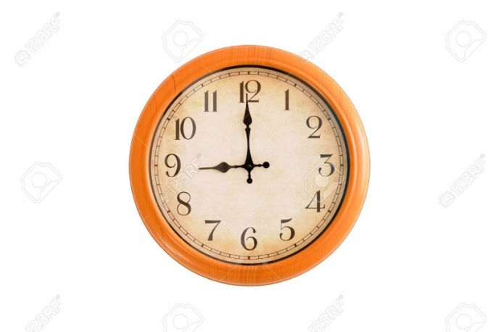

1. Start early at weekends i.e. 9am. That way, you'll get your day's work done in the morning and have the afternoon or evening to relax.
2. 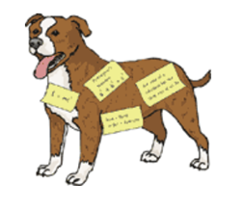Stick revision notes all around your house. That means that you’ll see important facts and quotes when you’re brushing your teeth or opening the fridge door! In your exam, you will think "Aha, volcanoes, they were stuck to bathroom mirror!”

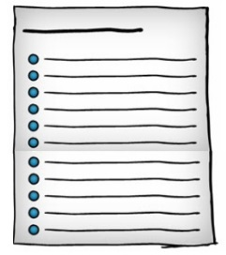

1. Don't just read your notes. You have to WRITE THINGS DOWN! Get used to summarising or reducing a full page of notes into a post-card sized couple of bullet-points.
2. Find the right environment to revise. NOT in front of the TV and NOT listening to the radio or surfing the internet. Music can sometimes be OK, but you need to find the right kind. It's got to be something that's just there in the background that you're not thinking about at all. Music without singing is better as you won't be tempted to join in.

**Over the next pages few pages you will find information about what is on your exams in each subject, as well as some more revision tips.**

|  |
| --- |
| **English Preparation Tips**   * **What is the test about?** Analytical task focused on a poem, followed by a short piece of descriptive writing based on personal experience. * **What do pupils need to revise?** Poetic techniques such as metaphor, simile, alliteration, onomatopoeia, personification, rhyme, rhythm, structure, etc. Also, pupils need to revise verbs, nouns, adjectives and PEE writing. * **What format of questioning is used?** Full sentence questions asking pupils to pick out particular words and phrases and to explain how the poet creates particular effects. * **What about the descriptive writing section?** It would also be useful to revise spelling, punctuation and grammar corrections. |
| **Maths Preparation Tips**   * **What is the test about?** Demonstrating fluency in numeracy and ability to apply mathematical techniques to problem solving. * **What do pupils use to revise?** They will be given a revision list and revision material to practise based questions via SMHW. * **What format of questioning is used?** There will be one non calculator exam paper |
| **Science Preparation Tips**  **What is the test about?** Demonstrating practical skills in science. This covers each aspect of the scientific process, from selecting apparatus, planning, recording results in tables, recognising safety risks, graph drawing and identifying trends in data.   * **What do pupils use to revise?** Worksheets and example questions will be provided on SMHW of skills based questions. Pupils should use their exercise books which contain relevant notes. * **What format of questioning is used?** Pupils will be given an investigation to plan, complete and analyse. Pupils will be required to write extended answers in planning, analysing and evaluating their experiment, and will be expected to make their own tables and graphs. Pupils will be assessed on the following criteria: Planning, safety (in planning and whilst using equipment), recording results, analysing results, evaluating experiments and independence. |
| **Art Preparation Tips**   * **What is the test about?** The careful execution of research about an artist related to their current project work. How the formal elements of art are used when presenting art work. * **What do pupils use to revise?** Pupils will research an artist (set by their teacher.) Check SMHW if absent) * **What format of questioning is used?** Pupils will be given a set of instructions that they must follow carefully in order to satisfy the assessment criteria. They will need to write researched information into their own words, describe what the artist’s work is about, how it is made, how it makes them feel, etc, and express and justify an opinion. * **What about the practical demonstration?** They will have to present their artist research creatively through writing, drawing and using colour to demonstrate their understanding of how to make effective use of space and the other formal elements of art used to present their work. For the smooth running of the exam it is IMPORTANT that pupils come prepared with their own equipment: A pencil, pen, ruler, sharpener, rubber and a set of colouring pencils. |

|  |
| --- |
| **Dance Preparation Tips**   * **What is the test about?** Demonstrating an understanding of Dance terminology and the principles of Dance. * **What do pupils use to revise?** They will be given a revision sheet via SMHW with all necessary material. Paper copies can be available also where needed. * **What format of questioning is used?** Spellings & definitions of some words, answers based on choreography & performance skills plus extended questions. * **What about the extended writing section?** This will be the pupils’ own interpretations of how to communicate a theme/ idea through movement and how choreographic tools can be used to communicate this idea with reasoning. They will also have to consider what makes a good piece of choreography. |
| **Drama Preparation Tips**   * **What is the test about?** Learning Drama terminology and Genres. * **What do pupils use to revise?** They will be given a revision sheet via SMHW with all necessary material. Paper copies can be available also where needed. * **What format of questioning is used?** A PowerPoint presentation. Simple answers based on questions about the units covered. * **What about the extended writing section?** This will be based on peer marking to develop their understanding of answers and showing the ability to correct their peers. |
| **Design and Technology Tips**   * **What is the test about?** Drawing accurately and skilfully. Answering questions about tools, equipment and materials they have used this year. * **What do pupils use to revise?** They will be given a revision sheet via SMHW with all necessary material. Paper copies can be available also where needed. * **What format of questioning is used?** Multiple choice and picture identification. Other questions will be asking for knowledge recall and will need no more than a sentence in answer. |

|  |
| --- |
| **Food Technology tips**   * **What is the test about?** Understanding nutrition in the diet and how to incorporate it into your diet. * **What do pupils use to revise?** They will be given a revision sheet via SMHW with all necessary material. Paper copies can be available also where needed. * **What format of questioning is used?** The majority of the questions will be multiple choice with 3 comprehensive questions at the end. * **What about the extended writing section?** This will be the pupils’ own summary of the year including which areas they have enjoyed the most and how food technology could be developed in the future. |
| **French Tips**   * **What is the test about?** Listening and reading test on house and home * **What do pupils use to revise?** Pupils will need to use their exercise book to revise the work done through year 7 so far. There is also a revision sheet for the modules covered available via Show My Homework. * **What format of questioning is used?** Mostly multiple choice questions, giving the answers as numbers, letters or short phrases in English. |
| **Geography Tips**   * **What is the test about?** The exam covers the three completed topics that have been studied so far in Year 8 – sport, rivers & flooding and Brazil. There is also a section on OS map skills. * **What do pupils use to revise?** Pupils have their exercise books and can also review lessons on the school VLE. * **What format of questioning is used?** The first section of the exam will consist of forty multiple-choice questions, followed by the extended writing section (see below). * **What about the extended writing section?** Pupils will be required to answer a quality-marked question (ten marks) based on a resource (i.e. map, graph, diagram) provided on the exam paper. They will have a choice of a physical geography question or a human geography question. |

|  |
| --- |
| **German Tips**   * **What is the test about?** Listening and reading test on health and food * **What do pupils use to revise?** Pupils will need to use their exercise book to * revise the work done through year 7 so far. There is also a revision sheet for the modules covered available via Show My Homework. * **What format of questioning is used?** Mostly multiple choice questions, giving the answers as numbers, letters or short phrases in English. |
| **History Tips**   * **What is the test about?** The aim of the exam is to help students to improve their understanding of how to revise effectively. The test will consist of questions on the following topics; Henry VII, Henry VIII, Elizabeth, Slavery and the British Empire. * **What do pupils use to revise?** The exam will be on the work they have done throughout the year. Students can revise from their exercise books. There will also be revision sheets on SMHW. * **What format of questioning is used?** There will be 40 multiple choice questions. |
| **ICT Tips**   * **What is the test about?** To demonstrate an understanding of E Safety, Spreadsheets, Databases, HTML, Hardware, Software & Web Design software applications. * **What do pupils use to revise?** Pupils will be given a homework sheet via SMHW with all necessary revision material they will need for the exam. * Paper copies will also be available upon request. * **What format of questioning is used?** Simple multi-choice & short sentence type answers. |
| **Music Tips**   * **What is the test about?** Each exam will focus on all topics covered up to the point of the test. * **What do pupils use to revise?** Revision materials will be provided on SMHW. * **What format of questioning is used?** There will be a mixture of multiple choice questions and open-ended questions. |

|  |
| --- |
| **Religious Studies Tips**   * **What is the test about?** This test is about retention and recall of information. * **What do pupils use to revise?** This test will be on work they have covered so far throughout the year - pupils therefore need to revise from their exercise books. * **What format of questioning is used?** The question format will be multiple choice/short answer. |

**Over the next pages few pages, you will find space to record what mark you received for each exam as well as your WWW (What Went Well) comment and your EBI (Even Better If) target. It is your responsibility to complete this section. Your teachers will make time in lessons for you to do this. When you have written in all your marks, your WWW and your EBI, you must ask your parent or carer to sign below and note down any comments about how you did in your Bridgewater Year 8 Exams Experience. Your form tutor will then sign this.**

**Signature of Parent/Carer __________________________________**

**Comments:**

**Signature of Form Tutor ____________________________________**

|  |
| --- |
| English mark : |
| WWW |
| EBI |

|  |
| --- |
| Maths mark : |
| WWW |
| EBI |

|  |
| --- |
| Science mark : |
| WWW |
| EBI |
| Art mark : |
| WWW |
| EBI |

|  |
| --- |
| Dance mark : |
| WWW |
| EBI |

|  |
| --- |
| Drama mark : |
| WWW |
| EBI |

|  |
| --- |
| Design and Technology mark : |
| WWW |
| EBI |

|  |
| --- |
| Food Technology mark : |
| WWW |
| EBI |

|  |
| --- |
| French / German mark : |
| WWW |
| EBI |

|  |
| --- |
| Geography mark : |
| WWW |
| EBI |

|  |
| --- |
| History mark : |
| WWW |
| EBI |

|  |
| --- |
| ICT mark : |
| WWW |
| EBI |

|  |
| --- |
| Music mark : |
| WWW |
| EBI |

|  |
| --- |
| Religious Studies mark : |
| WWW |
| EBI |

**Exam Reflection**

Here you can write down what you personally were pleased about in your exams and anything you felt disappointed with. This might not be the same as WWW and EBI. You might reflect on how much revision you did for particular aspects of the exam and how hard you worked during the exam itself. You might explain whether a particular result came as a surprise to you (a nice surprise hopefully, but this might not always be the case. Think about what you gained from the experience. Did all your revision pay off or did you realise that you needed to start revising a bit earlier? What have you learned about how to use your time, both during revision time and in the exam itself? What would you do differently next time?

|  |
| --- |
|  |
|  |
|  |
|  |
|  |
|  |
|  |
|  |
|  |
|  |
|  |
|  |
|  |
|  |