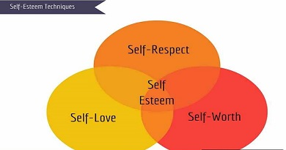

SELF HELP
HOW TO INCREASE YOUR SELF ESTEEM
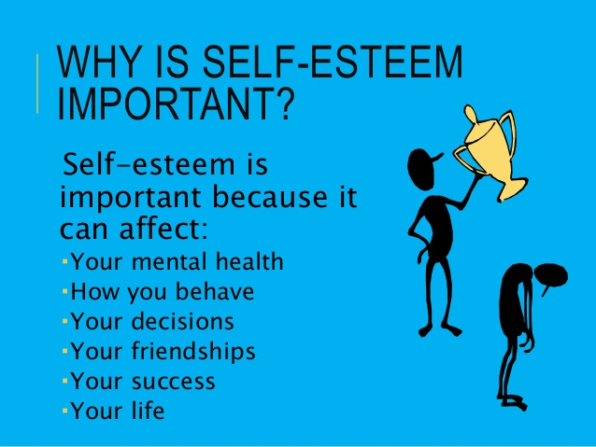

WHAT IS SELF-ESTEEM?
Self-esteem is how you think about yourself. Being confident means being comfortable with how you look and how you feel. In addition, it means feeling good about yourself, your abilities and your thoughts.
If you have healthy self-esteem, your beliefs about yourself will generally be positive. You may experience difficult times in your life, but you will generally be able to deal with these without them having too much of a long-term negative impact on you.

If you have low self-esteem, your beliefs about yourself will often be negative. You will tend to focus on your weaknesses or mistakes that you have made, and may find it hard to recognise the positive parts of your personality. You may also blame yourself for any difficulties or failure that you have.

“PEOPLE THINK I AM CONFIDENT BECAUSE I CAN SPEAK IN A ROOM FULL OF PEOPLE. THE REALITY IS THAT I SPEND MOST OF MY TIME THINKING I AM NOT GOOD ENOUGH. IF I GIVE A SPEECH, I SPEND THE NEXT FEW DAYS THINKGING ABOUT ALL THE MISTAKES I MADE”

WHAT CAUSES LOW SELF-ESTEEM?
It is not possible to identify one cause of low self-esteem for everyone. You form your beliefs about yourself over a long period of time and this has likely been affected by a range of different things.
Some factors that can contribute to low self –esteem include:
- Difficult childhood experiences – negative experiences in childhood such as bullying, difficult family relationships or having a hard time at school, can be particularly damaging for your self-esteem.
- Personality and temperament – elements of your personality, such as a tendency towards negative thinking or finding it hard to relate to other people, could contribute to a poor self-image
- Feeling ‘different’ – feeling like the ‘odd one out’, or under peer pressure to conform to social norms you don’t agree with, can affect the way you see yourself.
- Relationships with other people – other people may feed into your low self-esteem, being negative about you or making you feel like you have little worth. On the other hand, you may feel you don’t live up to other people’s expectations.
- Negative thinking patterns – you may learn or develop thinking patterns to reinforce low self-esteem, such as constantly comparing yourself to others or developing high standards for yourself that you can’t achieve.
- Discrimination and stigma – if you are discriminated against for whatever reason, this can affect the way you see yourself.
- Social isolation and loneliness – if you have limited contact with other people, or find it hard to maintain relationships with other people, this can lead to poor self-image
- Trauma, abuse or bullying – trauma, physical, sexual or psychological abuse and bullying can all lead to feelings of guilt and low self-worth.
- Mental health problems. (see next page)

CYCLE OF LOW SELF-ESTEEM AND MENTAL HEALTH PROBLEMS
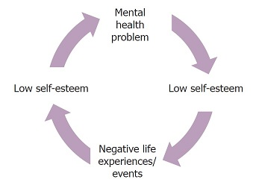
Low self-esteem and mental health problems can reinforce each other, creating an unhelpful cycle

“LOW SELF ESTEEM CONTRIBUTED TO MY DEVELOPING DEPRESSION – AND THE DEPRESSION MADE MY SELF-ESTEEM WORSE, AS I THOUGHT THAT IF I WERE A MORE WORTHWHILE PERSON, I’D BE BETTER ABLE TO COPE.”

WHAT CAN I DO TO BUILD MY SELF-ESTEEM

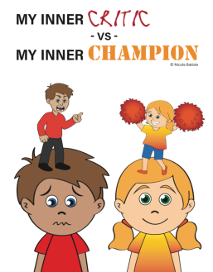
MANAGE YOUR INNER CRITIC – notice the critical things you say to yourself. Would you talk to a best friend like that? A harsh inner voice just tears us down. If you’re in the habit of thinking self-critically, re-train yourself by rewording these negative unkind thoughts into more helpful feedback.

FOCUS ON WHAT GOES WELL FOR YOU – are you so used to focusing on your problems that they’re all you see? Next time you catch yourself dwelling on problems or complaints about yourself or your day, find something positive to counter it. Each day, write down three good things about yourself and/or three things that went well that day because of your action or effort

AIM FOR EFFORT RATHER THAN PERFECTION – some people get held back by their own pressure to be perfect. They lose out because they don’t try. If you think, “I won’t audition for the play because I probably won’t get the lead,” it’s guaranteed that role will go to someone else.

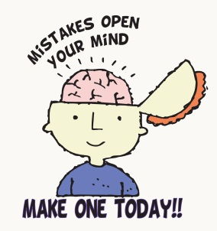
VIEW MISTAKES AS LEARNING OPPORTUNITIES – accept that you will make mistakes. Everyone does. They’re part of learning. Instead of thinking, “I always mess up” remind yourself that’s it’s not about always, just this specific situation. What can you do differently next time?

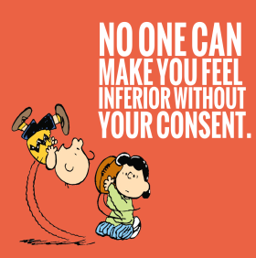
EDIT THOUGHTS THAT GET YOU FEELING INFERIOR – Do you often compare yourself with others and come up feeling less accomplished or less talented? Notice what you’re thinking. Something like “He’s so much better than I am. I’m no good at football. I should just stop playing” leads to feeling inferior, not to feeling good about yourself.

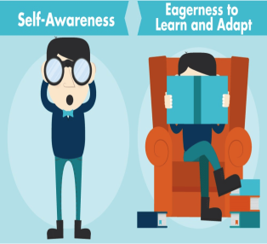
REMIND YOURSELF THAT EVERYONE EXCELS AT DIFFERENT THINGS – focus on what you do well, and cheer on others for their success. Thinking more like this: “He’s a great football player – but the truth is, I’m a better musician than athlete. Still. I’ll keep playing because I enjoy it” helps you to accept yourself and make the best of the situation.

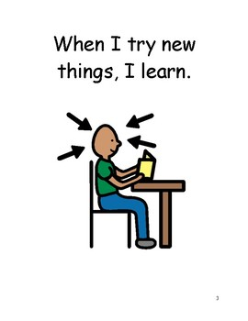
TRY NEW THINGS, AND GIVE YOURSELF CREDIT – experiment with different activities to help you get in touch with your talents. Then take pride in your new skills. Think about the good results. For example: I signed up for athletics and found out I’m pretty fast! These positive thoughts become good opinions of yourself, and add up to self-esteem

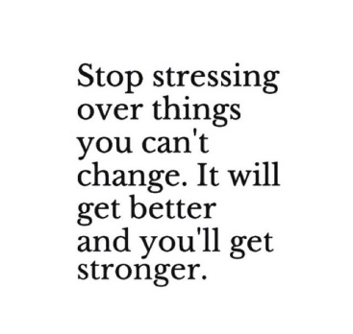
RECOGNISE WHAT YOU CAN CHANGE AND WHAT YOU CAN’T – if you realize something about yourself that you can change, start today. If it’s something you can’t change, work on accepting it. Obsessing about “flaws” can really skew your opinion of yourself and bring down your self-esteem. Most of the time, other people don’t even notice these things!

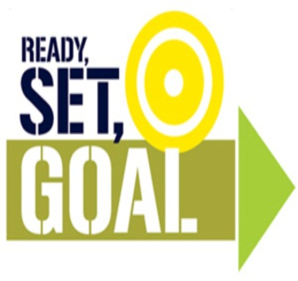
SET GOALS – think about what you’d like to accomplish. Then make a plan for how to do it. Stick with your plan, and keep track of your progress. Train your inner voice to remind you of what you are accomplishing. For example: “I’ve been following my plan to exercise every day for 45 minutes. I feel good that I’ve kept my promise to myself. I know I can keep it up.”

TAKE PRIDE IN YOUR OPINIONS AND IDEAS – don’t be afraid to voice them. If someone disagrees it’s not a reflection on your worth or your intelligence. That person just sees things differently from you.

ACCEPTING COMPLIMENTS – when self-esteem is low, it’s easy to overlook the good things people say about us. We don’t believe it when someone says a nice thing. Instead, we think. “…yeah, but I’m not all that great…” and we brush off the compliment. Instead, let yourself absorb a compliment, appreciate it, and take it seriously. Give sincere compliments, too.

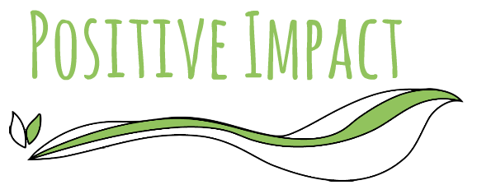
MAKE A CONTRIBUTION – tutor a classmate who’s having trouble, help clean up your neighbourhood, participate in a walkathon for a good cause, or volunteer your time in some other way. When you can see that what you do makes a difference, it builds your positive opinion of yourself. When you can see that what you do makes a difference, it builds your positive opinion of yourself, and makes you feel good. That’s self-esteem.
EXERCISE - being active and fit helps you to feel good about yourself. You’ll relieve stress and be healthier too!!

RELAX AND HAVE FUN – do you ever think stuff like “I’d have more friends if I were more attractive”? Thoughts like these can set you on a path to low self-esteem because they focus on what’s not perfect instead of making the best of what is. Spend time with people you care about, do the things you love, and focus on what’s good. That helps you feel good about yourself, just as you are.

LEARNING TO IDENTIFY AND CHALLENGE NEGATIVE BELIEFS

If you are going to improve your self-esteem, it may also help to understand more about your negative beliefs about yourself, and where they came from.

It might be helpful to write down notes, and questions such as these could help to structure your thoughts:
- What do you feel are your weaknesses or failings?
- What negative things do you think other people think about you?
- If you could sum yourself up, what word would you use – ‘I am…’
- When did you start feeling like this?
- Can you identify an experience or event that might have caused this feeling?
- Do you find you have certain negative thoughts on a regular basis?

As you identify what your core beliefs about yourself are, and where they come from, you can begin to challenge and change them. One way you can do this is to write down evidence to challenge each belief and begin to explore other explanations of the situation.
For example, if you think no one likes you, you can start to record situations that show a different pattern:
- I have been asked to a friend’s party on Saturday
- The girls asked me to go to town after school on Friday.
- I always have a group of friends around me at break and lunchtime and they always include me in what they are doing.
These might feel like small examples, but as your list gets longer over time you can look back at it and challenge the negative opinions that you have been holding on to.

FOCUS ON YOUR POSITIVES.
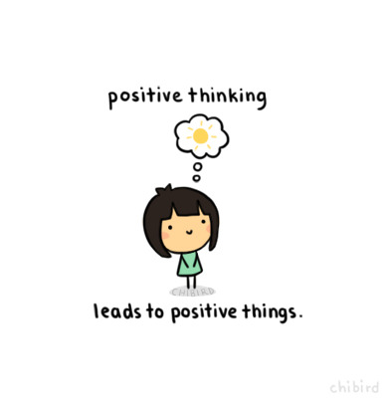

If you have low self-esteem, it can take practice to get used to thinking more positively about yourself. One way you can do this is by making a list of several things that you like about yourself. You might include:

- Things about your personality
- Things about the way you look
- Things that you do
- Skills you have developed

Take your time and aim for 50 different things, even if this takes several weeks. Keep this list and look at a different part of it each day. If you are feeling down or worried about an event that is coming up, you can use it to remind you of the good things about yourself.

If you struggle to come up with a list of good things, you could ask your friend or someone you trust to help you begin. This may also help you to see how others may have a higher opinion of you than you do yourself.

Another technique is to write down at least three things that went well or that you have achieved that day before you go to sleep. Some people also find it helpful to keep objects, such as photos or letters that make them feel good about themselves.

“I HAVE A FEEL-GOOD BOX, AND IN IT I KEEP HAPPY MEMORIES, POSITIVE AFFIRMATIONS AND JUST LITTLE THINGS THAT MAKE ME FEEL GOOD”

TRY MINDFULNESS TECHNIQUES
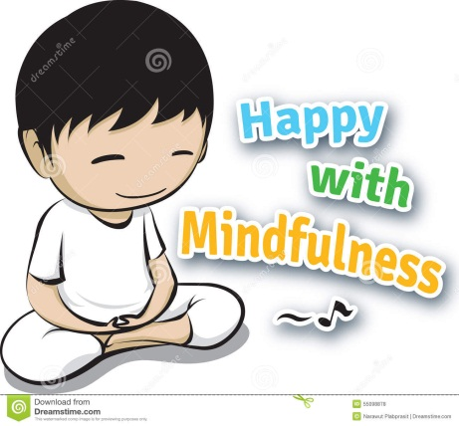
Mindfulness is a way of paying attention to the present moment, using techniques like meditation, breathing and yoga. It has been shown to help people become more aware of their thoughts and feelings, so that instead of being overwhelmed by them, it is easier to manage them. (Speak to Mrs Ward about what is available in school)

SELF-HELP RESOURCES.

Top tips to increase your self-esteem

Remember these top tips to help you build your self-esteem:
- Manage your inner critic
- Focus on what goes well for you
- Aim for effort rather than perfection
- View mistakes as learning opportunities
- Edit thoughts that get you feeling inferior
- Remind yourself that everyone excels at different things
- Try new things and give yourself credit
- Recognise what you can change and what you can’t
- Set goals
- Take pride in your opinions and ideas
- Accepting compliments
- Make a contribution
- Exercise
- Relax and have fun

POSITIVE THINGS ABOUT ME:
Use this space to write a list of positive things about you.
_____________________________________________________________________________________________________________________________________________________________________________________________________________________________________________________________________________________________________________________________________________________________________________________________________________________________________________________________________________________________________________________________________________________________________________________________________________________________________________________________________________________________________________________________________________________________________________________________________________________________________________________________________________________________________________________________________________________________________________________________________________________________________________________________________________________________________________________________________________________________________________________________________________________________________________________________________________________________________________________________________________________________________________________________________________________________________________________________________________________________________________________________________________________________________________________________________________________________________________________________________________________________________________________

CHALLENGING NEGATIVE THOUGHTS
Use this space to write down negative thoughts and give examples of how they aren’t true.
NEGATIVE THOUGHT | EVIDENCE AGAINST IT

USEFUL INFORMATION.
If you are struggling with your anxiety and would like to speak to someone in school there are a number of support systems in place:
- Speak to your PAM/PAL
- Go and see Mrs Flanagan/Mrs Brown in student support
- Mrs Ward Drop in session – where you can talk about your worries without needing a referral.
Outside of school, there are a number of good websites that can offer you advice and support.
- KOOTH
- YOUNG MINDS
- HAPPY/OK/SAD
Created by Mrs Ward – School mental health Lead (September 2018)

