SELF HELP
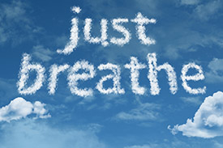
HOW TO DO CALM BREATHING

HOW TO DO CALM BREATHING.
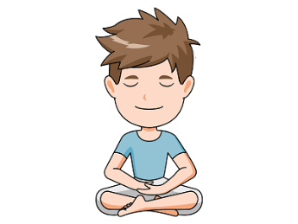
WHAT IS “CALM BREATHING”?
Calm breathing is a technique that helps you slow down your breathing when feeling stressed or anxious.

Why is Calm Breathing Important?
- Our breathing changes when we are feeling anxious. We tend to take short quick, shallow breaths, or even hyperventilate; this is called “over breathing”.
- It is a good idea to learn techniques for managing “over breathing”, because this type of breathing can actually make you feel even more anxious (e.g., due to a racing heart, dizziness, or headaches).
- Calm breathing is a great portable tool that you can use whenever you are feeling anxious. However, it does require some practice.
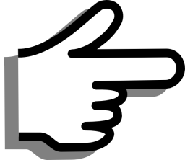
TIP: Like other anxiety – management skills, the purpose of calm breathing is not to avoid anxiety at all costs, but just to take the edge off or help you “ride out” the feelings.

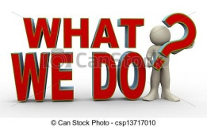
HOW TO DO IT:
Calm breathing involves taking smooth, slow, and regular breaths. Sitting upright is usually better than lying down or slouching, because it can increase the capacity of your lungs to fill with air. It is best to ‘take the weight’ off your shoulders by supporting your arms on the side arms of a chair, or on your lap.
- Take a slow breath in through your nose, breathing into your lower belly (for about 4 seconds)
- Hold your breath for 1 or 2 seconds
- Exhale slowly through the mouth (for about 4 seconds)
- Wait a few seconds before taking another breath
About 6-8 breathing cycles per minute is often helpful to decrease anxiety, but find your own comfortable breathing rhythm. These cycles regulate the amount of oxygen you take in so that you do not experience the fainting, tingling, and giddy sensations that are sometimes associated with over breathing.

HELPFUL HINTS:
- Make sure that you aren’t hyperventilating; it is important to pause for a few seconds after each breath
- Try to breath from your diaphragm or abdomen. Your shoulders and chest area should be fairly relaxed and still. If this is challenging at first, it can be helpful to first try this exercise by lying down on the floor with one hand on your heart, the other hand on your abdomen. Watch the hand on your abdomen rise as you fill your lungs with air, expanding your chest. (The hand over your heart should barely move, if at all)

TIP: RULES OF PRACTICE:
- Try calm breathing for at least five minutes twice a day
- You do not need to be feeling anxious to practice – in fact, at first you should practise while feeling relatively calm. You need to be comfortable breathing this way when feeling calm, before you can feel comfortable doing it when anxious. You’ll gradually master this skill and feel the benefits!
- Once you are comfortable with this technique, you can start using it in situations that cause anxiety.
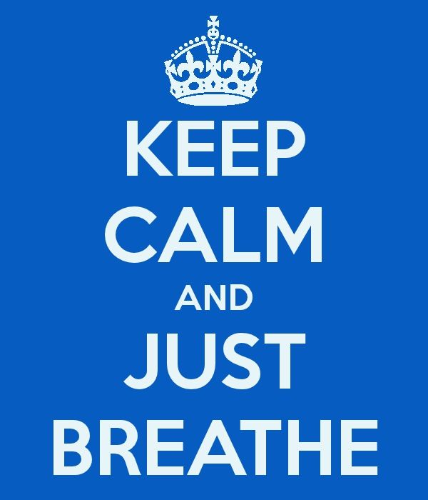

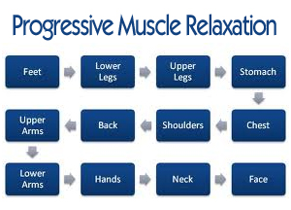
SELF HELP

PROGRESSIVE MUSCLE RELAXATION

HOW TO DO PROGRESSIVE MUSCLE RELAXATION.
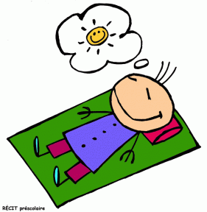
Progressive Muscle Relaxation teaches you how to relax your muscles through a two-step process. First, you systematically tense particular muscle groups in your body, such as your neck and shoulders. Next, you release the tension and notice how your muscles feel when you relax them. This exercise will help you to lower your overall tension and stress levels, and help you relax when you are feeling anxious. It can also help reduce physical problems such as stomach-aches and headaches, as well as improve your sleep
People with anxiety difficulties are often so tense throughout the day that they don’t even recognise what being relaxed feels like. Through practice you can learn to distinguish between the feelings of a tensed muscle and a completely relaxed muscle. Then, you can begin to “cue” this relaxed state at the first sign of the muscle tension that accompanies your feelings of anxiety. By tensing and releasing, you learn not only what relaxation feels like, but also to recognise when you are starting to get tense during the day.
TIP:
- Set aside about 15 minutes to complete this exercise
- Find a place where you can complete this exercise without being disturbed
- For the first week or two, practise this exercise twice a day until you get the hang of it. The better you become at it, the quicker the relaxation response will “kick in” when you really need it.
- You do not need to be feeling anxious when you practise this exercise. In fact. It is better to first practise it when you are calm. That way, it will be easier to do when feeling anxious.

GETTING READY
Find a quiet, comfortable place to sit then close your eyes and let your body go loose. A reclining armchair is ideal. You can lie down, but this will increase your chances of falling asleep. Although relaxing before bed can improve your sleep, the goal of this exercise is to learn to relax while awake. Wear loose, comfortable clothing, and don’t forget to remove your shoes. Take about five slow, deep breaths before you begin.

HOW TO DO IT:
THE TENSION – RELAXATION RESPONSE.
STEP 1: Tension.
The first step is applying muscle tension to a specific part of the body. This step is essentially the same regardless of which muscle group you are targeting. First, focus on the target muscle group, for example, your left hand. Next, take a slow, deep breath and squeeze the muscles as hard as you can for about 5 seconds. It is important to really feel the tension in your muscles, which may even cause a bit of discomfort or shaking. In this instance, you would be making a tight fist with your left hand.
It is easy to accidentally tense other surrounding muscles (for example, the shoulder or arm), so try to ONLY tense the muscles you are targeting. Isolating muscle groups gets easier with practice.
TIP:
BE CAREFUL!! Take care not to hurt yourself when tensing your muscles. You should never feel intense or shooting pain while completing this exercise. Make the muscle tension deliberate, yet gentle.

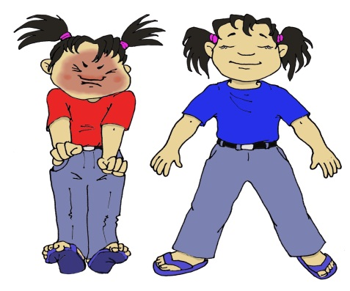
STEP 2: Relaxing the Tense Muscles:
This step involves quickly relaxing the tensed muscles. After about 5 seconds, let all the tightness flow out of the tensed muscles. Exhale as you do this step. You should feel the muscles become loose and limp, as the tension flows out. It is important to very deliberately focus on and notice the difference between the tension and relaxation. This is the most important part of the whole exercise.

Note: It can take time to learn to relax the body and notice the difference between tension and relaxation. At first, it can feel uncomfortable to be focusing on your body, but this can become quite enjoyable over time.

Remain in this relaxed state for about 15 seconds, and then move on to the next muscle group. Repeat the tension-relaxation steps. After completing all of the muscle groups, take some time to enjoy the deep state of relaxation.

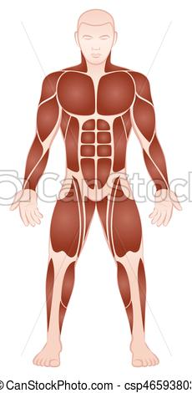
THE DIFFERENT MUSCLE GROUPS.

During this exercise, you will be working with almost all the major muscle groups in your body. To make it easier to remember, start with your feet and systematically move up (or if you prefer, you can do it in the reverse order, from your forehead down to your feet). For example:

- Foot (curl your toes downward)
- Lower leg and foot (tighten your calf muscle by pulling toes towards you)
- Entire leg (squeeze thigh muscles while doing the above)
(Repeat on other side of the body)
- Hand (clench your fist)
- Entire right arm (tighten your biceps by drawing your forearm up towards your shoulder and ‘make a muscle’, while clenching fist)

(Repeat on other side of the body)

- Buttocks (tighten by pulling your buttocks together)
- Stomach (suck your stomach in)
- Chest (tighten by taking a deep breath)
- Neck and shoulders (raise your shoulders up to touch your ears)
- Mouth (open your mouth wide enough to stretch the hinges of your jaw)
- Eyes (clench you eyelids tightly shut)
- Forehead (raise your eyebrows as far as you can)
It can be helpful to listen to someone guide you through these steps. There are apps for your phone that you can download, and also scripts online.
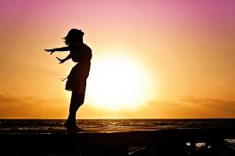
QUICK TENSE AND RELAX!
Once you have become familiar with the ‘tension and relaxation’ technique, and have been practising it for a couple of weeks, you can begin to practice a very short version of progressive muscle relaxation. In this approach, you learn how to tense larger groups of muscles, which takes even less time. These muscle groups are:
- Lower limbs (feet and legs)
- Stomach and chest
- Arms, shoulders and neck
- Face
So instead of working with just one specific muscle group at a time (e.g., your stomach), you can focus on the complete group (your stomach AND chest). You can start by focusing on your breathing during the tension and relaxation. When doing this shortened version, it can be helpful to say a certain word or phrase to yourself as you slowly exhale (such as “relax”, “let go”, “stay calm”, “peace” “it will pass” etc…). This word or phrase will become associated with a relaxed state, eventually; saying this word alone can bring on a calm feeling. This can be handy during times when it would be hard to take the time to go through all the steps of progressive muscle relaxation.
RELEASE ONLY
A good way to even further shorten the time you take to relax your muscles is to become familiar with the “release only” technique. One of the benefits of tensing and releasing muscles is that you learn to recognise what tense muscles feel like and what relaxed muscles feel like.
Once you feel comfortable with the tension and relaxation techniques, you can start doing “release only”, which involves removing the “tension” part of the exercise. For example, instead of tensing your stomach and chest before relaxing them, try just relaxing the muscles. At first, the feeling of relaxation might feel less intense then when you tensed the muscles beforehand, but with practice, the release only technique can be just as relaxing.
TIP: Remember to practice progressive muscle relaxation often, whether you are feeling anxious or not. This will make the exercise even more effective when you really do need to relax! Though it may feel a bit tedious at first, ultimately you will gain a skill that will probably become a very important part of managing your anxiety in your daily life

