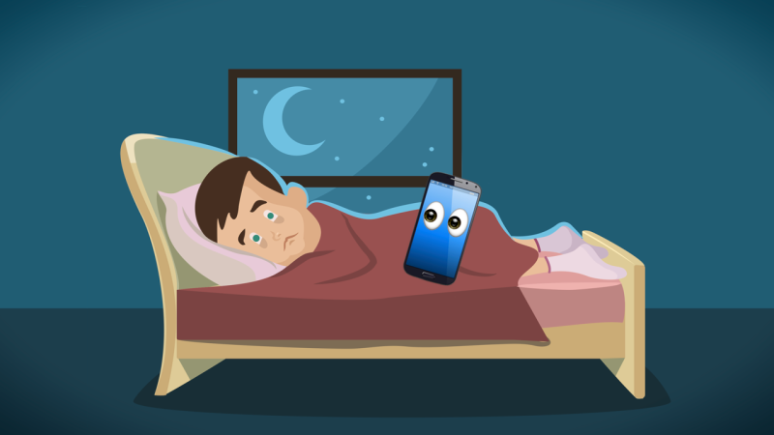

IMPROVING MY SLEEP.

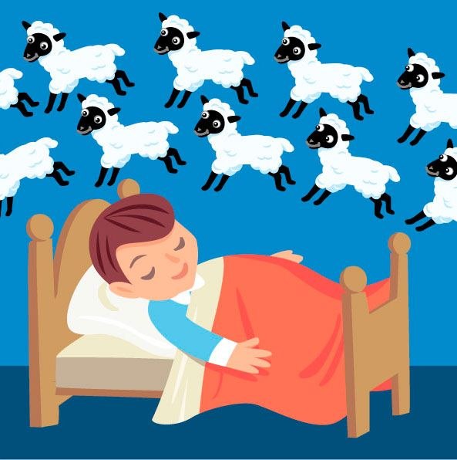

HOW TO COPE WITH SLEEP PROBLEMS
There is a close relationship between sleep and Mental Health. Living with a Mental Health problem can affect how well you sleep, and poor sleep can have a negative impact on your Mental Health.

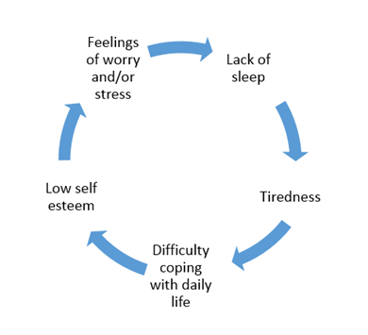

POOR SLEEP LEADS TO WORRYING. WORRYING LEADS TO POOR SLEEP.WORRYING BOUT SLEEP IS LIKE YOUR MIND TRYING TO FIGHT ITSELF. THAT’S A HORRIBLE PLACE TO BE
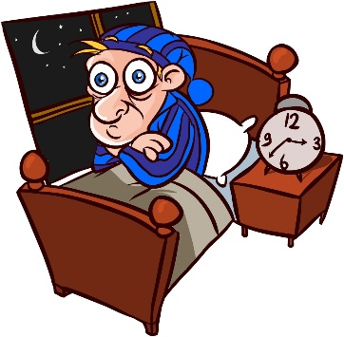

WHAT ARE SLEEP PROBLEMS?
If poor sleep is having a significant impact on your daily life, it is likely you will be considered to have a sleep problem.
You may find a sleep problem can lead you to:
- Have negative thoughts, feel low in mood. If you have little sleep you may feel less able to rationalise worries or irrational thoughts.
- Feel lonely or isolated – if you feel tired you may not want to be sociable or see friends

SLEEP PROBLEMS CAN BE A SIGN OF DECLINING MENTAL HEALTH. THE WORSE YOU SLEEP, THE LESS ABLE YOU MAY BE TO COPE DURING THE DAY. THE LESS YOU ARE COPING, THE WORSE YOU WILL SLEEP.

HOW CAN MY MENTAL HEALTH PROBLEM AFFECT MY SLEEP?

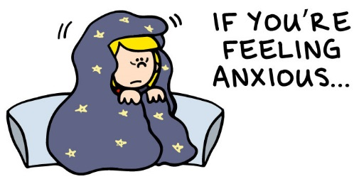
- ANXIETY–can cause thoughts to race through your mind, making it difficult to sleep

- DEPRESSION – can lead to oversleeping – either sleeping late in the morning or sleeping a lot during the day. If you experience difficult or troubling thoughts as part of depression, this can also cause insomnia

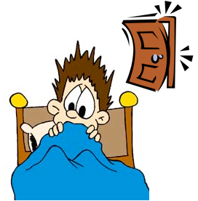
- PARANOIA – may make it difficult for you to sleep. You may hear voices/noises or see things that you find frightening, or experience disturbing thoughts, which make it difficult for you to get to sleep.

TIPS FOR WHEN YOU CANT SLEEP
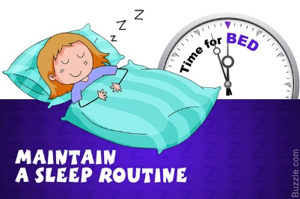

ESTABLISH A ROUTINE – Try to establish a regular sleeping pattern by going to bed and waking up at roughly the same time every day. Go to bed only when you feel tired enough to sleep. Then get up at the usual time. This may mean that you actually spend less time in bed, but more of the time in bed asleep.
Be consistent on weekends. Although you can stay up a little longer, you should try and not sleep in to catch up on sleep you have missed during the week. It will make it harder to get back on track

ROUTINE, ROUTINE, ROUTINE. PREPARING YOUR BODY FOR SLEEP, LETTING YOURSELF KNOW THAT IT IS TIME TO WIND DOWN. THEN IN THE MORNING SET A TIME TO GET UP AND STICK TO IT NO MATTER WHAT.

RELAX BEFORE YOU GO TO BED – You may find a routine can help you prepare for sleep. There are several things you can try:

- Do something calming – such as listening to music, or having a bath
- Breathing exercises – in a comfortable position, try this: breathe into your belly (not your chest) then out through your nose, making your out-breath longer than your in-breathe; repeat until you feel relaxed.
- Muscle relaxation – consciously tense and relax your muscles, one after the other, starting with your toes and working up your body until you reach the top of your head.
- Visualisation – picture a scene or landscape that has pleasant memories for you
- Meditation – you can learn meditation techniques at a class or from self-help guides; many people find mindfulness helpful. (Speak to Mrs Ward to see what is available in school)

MAKE SURE WHERE YOU SLEEP IS COMFORTABLE

You may want to experiment with the temperature, light and noise levels to work out what works best for you. Overall, dark, quiet and cool environments generally make it easier to sleep, but this will vary from person to person. A bedroom that is warmer than 75 degrees can make it harder to fall and stay asleep
The bed should only be used for sleeping. Try not to do homework, read a book or listen to music in

KEEP A SLEEP DIARY You may find it difficult to work out what is affecting your sleep. A sleep diary involves recording information about your sleep habits to help you understand your sleep problem and what is affecting it. If you want to, you can show it to the professionals you are working with, so you can work together to understand the problem you are having

A SLEEP DIARY COULD INCLUDE INFORMATION ABOUT:
- What time you go to bed and what time you get up
- Total number of hours sleep
- Overall quality of sleep, ranked 1 – 5
- How many times you wake up in the night, how long you are awake and what you do while you are awake
- Whether you have nightmares, night terrors or sleep paralysis, or have sleepwalked during the night
- Whether you sleep during the day, and for how long
- Any medication you’re taking, including dose and what time you take it
- The amount of caffeine, alcohol or nicotine you have
- The amount of exercise you do
- What you eat and drink
- Your general feelings and mood, including any anxious and repetitive thoughts

Daily Sleep Diary
Complete the diary each morning (“Day 1” will be your first morning). Don’t worry too much about giving exact answers, an estimate will do?
Your Name___________________________ The date of Day 1_______________

Enter the weekday | DAY 1 | DAY 2 | DAY 3 | DAY 4 | DAY 5 | DAY 6 | DAY 7
1. At what time did you go to bed last night?
2. After settling down how long did it take you to fall asleep?
3. After falling asleep, about how many times did you wake up in the night?
4. After falling asleep, for how long were you awake during the night in total?
5. At what time did you finally wake up?
6. At what time did you get up?
7. How long did you spend in bed last night (from first getting in to finally getting up?)
8. How would you rate the quality of your sleep last night?
1 Very poor
5. Very good

TRY TO RESOLVE STRESS AND WORRIES

Try to identify anything in your life that’s causing you stress or worry that might be affecting your sleep. You may find it helpful to talk to a friend about the thoughts and feelings that affect your sleep, or write them down.

“I found meditation and writing down my feelings in a little notebook before I settled down for bed really helped”

Once you’ve identified what’s causing your sleep problems, there may be practical measures you can take to address the problem – such as finding ways to manage anxiety, or talking to a trusted adult.

GIVE YOURSELF TECH FREE TIME
Use of bright screens on laptops and phones in the evening has been shown to negatively affect sleep.
Try to give yourself some tech free time an hour or so before bed, to help prepare yourself for sleep.
“I avoid my phone or TV – instead I listen to soothing music or read a book”

FOOD DRINK AND EXERCISE
Caffeine and sugary foods may give short-term help but they can all disturb your sleep patterns.
Doing regular physical activity can also help you sleep, as it makes your more physically tired – particularly if your exercise outdoors.

“When I’m suffering from sleep problems it’s usually the result of not getting enough exercise and staying in bed”

USEFUL INFORMATION.
The Royal college of Psychiatrists www.rcpsych.ac.uk/mentalhealthinformation/mentalhealthproblems/sleepingwell.aspx
Mind
www.mind.orf.uk/information-support/types-of-mental-health-problems.anxiety-and-panic-attacks
Young Minds
www.youngminds.org.uk/sleep

USEFUL FACTS

1. Teens need 8.5 to about 9 hours sleep to feel refreshed and ready to learn the next day.

2. Sleeping in a quiet, dark bedroom, going to bed at the same time every night and exercising during the day all help to get a good night’s sleep.

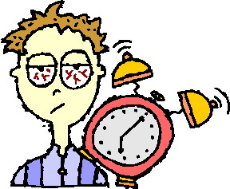

3. Difficulty waking up in a morning, inability to concentrate, falling asleep during class and feeling moody or depressed are all signs that a person may not be getting enough sleep.

