SELF HELP GUIDE

REALISTIC THINKING
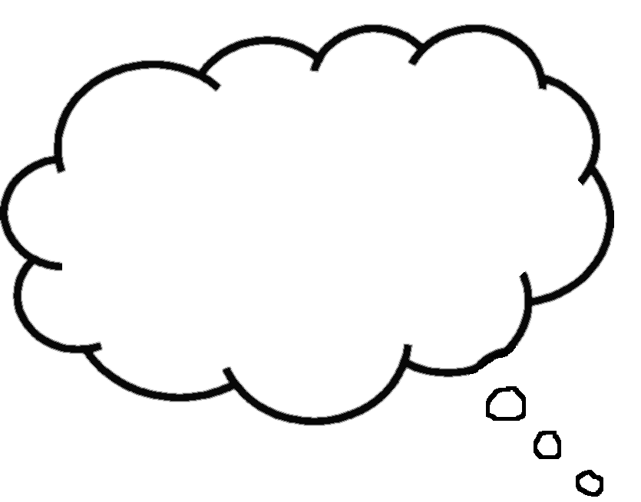

REALISTIC THINKING
We can all be bogged down by negative thinking from time to time, such as calling ourselves mean names (e.g., “idiot”, “loser”). Thinking no one likes us, expecting something terrible will happen, or believing that we can’t overcome something no matter how hard we try. This is normal. No one thinks positively all the time, particularly when feeling anxious.

When we are anxious, we tend to see the world as a threatening and dangerous place. This reaction makes sense, because imagining the worst can help you to prepare for real danger, enabling you to protect yourself. For example, if you are home alone and you hear a strange scratching sound at the window, you might think it’s a burglar. If you believe that it’s a burglar, you will become very anxious and prepare yourself to either run out of the house, fight off an attack, or run to the phone and call for help. Although this anxious response is helpful if there actually is a burglar at the window, it is not so helpful if your thought was wrong: for example, it might be a tree branch scratching the window. In this case, your thoughts were wrong because there was no real danger.

The problem with thinking and acting as if there is danger when there is actually no real danger is that you feel unnecessarily anxious. Therefore, one effective strategy to manage your anxiety is to replace your anxious, negative thinking with realistic thinking.

Realistic thinking means looking at all aspects of a situation (the positive, the negative, and the neutral) before making conclusions. In other words, realistic thinking means looking at yourself, others, and the world in a balanced and fair way.

HOW TO DO IT

STEP 1 – Pay attention to your self-talk
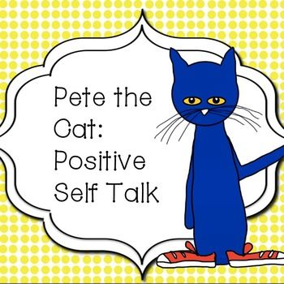
Thoughts are the things that we say to ourselves without thinking out loud (self-talk). We can have many thoughts every hour of the day. We all have our own way of thinking about things, and how we think has a big effect on how we feel. When we feel that something bad will happen – such as being bitten by a dog – we feel anxious. Realistic thinking means looking at all aspects of a situation (the positive, the negative, and the neutral) before making conclusions. In other words, realistic thinking means looking at yourself, others, and the world in a balanced and fair way……..For example, imagine that you are out for a walk and you see a dog. If you think the dog is dangerous and will bite, you will feel scared. But, if you think the dog is cute you will feel calm.

FEELING:
Calm
THOUGHT:
“That dog is so cute”
FEELING:
Scared, anxious

THOUGHT:
“The dog is dangerous and is going to bite me”
SITUATION:
You see a dog

Often, we are unaware of our thoughts, but because they have such a big impact on how we feel, it is important to start paying attention to what we are saying to ourselves.
Step 2: Identify thoughts that lead to feelings of anxiety
It can take some time and practice to identify the specific thoughts that make you anxious, so here are some helpful tips:
Pay attention to your shifts in anxiety, no matter how small. When you notice yourself getting more anxious, that is the time to ask yourself:
- “What am I thinking right now?”
- “What is making me feel anxious?”
- “What am I worried will happen?”
- “What bad thing do I expect to happen?”
Some examples of “anxious” thoughts:
- “What if I can’t do it?”
- “I’m going to die of a heart attack!”
- “People are going to laugh at me if I mess up during the presentation.”
- “I’m going to go crazy if I can’t stop feeling so anxious”
- “Things are not going to work out.”
- “I’m an idiot”
- “What if something bad happens to one of my parents?”

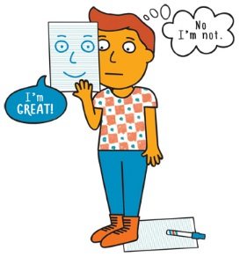
Step 3: Challenge your “anxious” thinking
Thinking about something does not mean that the thought is true or that it will happen. For example, thinking that a dog will bite you does not mean that it will. Often, our thoughts are just guesses and not actual facts. Therefore, it is helpful to challenge your anxious thoughts, because they can make you feel like something bad will definitely happen, even when it is highly unlikely.
Sometimes, our anxiety is the result of falling into thinking traps. Thinking traps are unfair or overly negative ways of seeing things. Use the Thinking Traps Form at the end of this booklet to help you identify the traps into which you may have fallen.

CHALLENGING NEGATIVE THINKING

Here are some questions to help you challenge your anxious thoughts:
- Am I falling into a thinking trap (e.g. catastrophizing or over estimating danger)?
- What is the evidence that this thought is true? What is the evidence that this thought is not true?
- Have I confused a thought with a fact?
- What would I tell a friend if he/she had the same thought
- What would a friend say about my thought?
- Am I 100% sure that _______________________ will happen?
- How many times has _______________________ happened before?
- Is ________________________ so important that my future depends on it?
- What is the worst that could happen?
- If it did happen, what can I do to cope with it or handle it?
- Is my judgement based on the way I feel instead of facts?
- Am I confusing “possibility” with “certainty”? It may be possible, but is it likely?
- Is this a hassle or a horror?

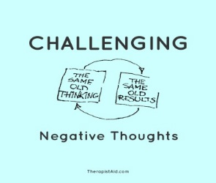
Here is an example to help you challenge your negative thinking:
If you have an important interview tomorrow and have been feeling quite anxious about it, you may think: “I’m going to mess up on the interview tomorrow.”

To challenge this thought, you can ask yourself the following questions:
- Am I falling into a thinking trap?
Yes, I have fallen into the trap of fortune telling, predicting that things will turn out badly before the event even takes place. But I still feel like I’ll definitely mess up.
- Am I basing my judgement on the way I “feel” instead of the “facts”
I might feel like I’m going to mess up, but there is no evidence to support it. I’m very qualified for the position. I have had interviews in the past and generally they have gone well.
- Am I 100% sure that I will mess up?
No, but, what if I mess up this time?
- Well, what’s the worst that could happen? If the worst did happen, what could I do to cope with it?
The worst that could happen is that I don’t get the job that I really wanted. It’ll be disappointing, but it won’t be the end of the world. I can always ask for feedback to see whether there is anything I can do to improve my chances of getting another position similar to this one . Use the Realistic Thinking Form at the back of this booklet to regularly write down thoughts that make you anxious, and use the Challenging Negative Thinking to help you replace your anxious thoughts with more realistic ones.

What you should know about Challenging thoughts.
- Challenging unhelpful thinking can be difficult at first – often it feels forced and
unnatural
- Like any new skill, thought challenging gets easier with practice
- You need to set aside time to practice thought challenging
- It’s often hardest to try thought challenging when you’re feeling highly depressed or anxious. Therefore, it is recommended that you first start practicing thought challenging when you feel less distressed.
- Thoughts and unhelpful thinking styles are like habits. Like any other habit, you need lots of practice to be able to change them effectively.
- It is important to be realistic with your expectations about this skill. You won’t master it immediately. However, it will become easier (and more automatic) with practice.
Step 4: More on helpful and realistic ways of thinking
More tips on helpful thinking:
Tip 1: Coping Statements. Try coming up with statements that remind you how you can cope with a situation. For example, “If I get anxious, I will try some calm breathing”, “I just need to do my best”, “People cannot tell when I am feeling anxious”, “This has happened before and I know how to handle it”, or “My anxiety won’t last forever”.
Tip 2: Positive self-statements. Regularly practise being “kind” to yourself (say positive things about yourself), rather than being overly self-critical. For example, instead of saying, “I will fail”, say something like, “I can do it”. Or “, I am not weak for having anxiety. Everyone experiences anxiety”, “I’m not a loser if someone doesn’t like me. No one is liked by everyone”, or “I’m strong for challenging myself to face the things that scare me”.
Tip 3: Alternative balanced statements based on challenging negative thoughts. Once you’ve looked at the evidence or recognised that you’ve fallen into a thinking trap, come up with a more balanced thought.
It can be tough to remember helpful thoughts or realistic coping statements when you are anxious. Try making up coping cards that include helpful statements. To make a coping card, write down your realistic thoughts on an index card or a piece of paper, and keep it with you (in your purse, bag). It can be helpful to read this card daily, just as a reminder

THINKING TRAPS
THINKING TRAPS | EXAMPLES
Fortune telling:  This is when we predict that things will turn out badly. But, in reality, we cannot predict the future because we don’t have a crystal ball | “I know I’ll mess up”  “I will never be able to manage my anxiety”
Black and white thinking:  This is when we only look at situations in terms of extremes. For example, things are either, good or bad, a success or a failure. But, in reality, most events call for a more ‘moderate’ explanation. For example, cheating once on your diet does not mean you have failed completely. You had a small setback, and all you need to do is get back on your diet tomorrow. | “Anything less than perfect is a failure”  “I planned to eat only healthy foods, but I had a piece of chocolate cake. Now my diet is completely ruined”
Mind reading:  This trap happens when we believe that we know what others are thinking and we assume that they are thinking the worst of us. The problem is that no one can read minds, so we don’t really know what others are thinking! | “Others think I’m stupid”  “She doesn’t like me”
Over-generalization:  This is when we use words like ‘always’ or ‘never’ to describe situations or events. This type of thinking is not helpful because it does not take all situations or events into account. For example, sometimes we make mistakes, but we don’t always make mistakes. | “I always make mistakes”  “I’m never good at public speaking”
Labelling: Sometimes we talk to ourselves in mean ways and use a single negative word to describe ourselves. This kind of thinking is unhelpful and unfair. We are too complex to be summed up in a single word! | “I’m stupid”  “I’m a loser”

Over estimating danger: This is when we believe that something that is unlikely to happen is actually right around the corner. It’s not hard to see how this type of thinking can maintain your anxiety. For example, how can you not feel scared if you think that you could have a heart attack any time? | “I will faint”  “I’ll go crazy”  “I’m dying”
Filtering: This happens when we only pay attention to the bad things that happen, but ignore all the good things. This prevents us from looking at all aspects of a situation and drawing a more balanced conclusion. | Believing that you did a poor job on a presentation because some people looked bored, even though a number of people looked interested and you received several compliments on how well you did.
Catastrophizing: This is when we imagine that the worst possible thing is about to happen, and predict that we won’t be able to cope with the outcome. But, the imagined worst-case scenario usually never happens and even if it did, we are most likely able to cope with it. | “I’ll freak out and no one will help”  “I’m going to make such a fool of myself, everyone will laugh at me, and I won’t be able to survive the embarrassment”
Should statements: This is when you tell yourself how you “should”, “must”, or “ought” to feel and behave. However, this is NOT how you actually feel or behave. The result is that you are constantly anxious and disappointed with yourself and/or others around you. | “I should never feel anxious”  “I must control my feelings”  “I should never make mistakes”

MORE COMMON COPING STATEMENTS

There is no need to panic | I have time for me
I can get through this | I deserve a break
It doesn’t need to be perfect…….my best is good enough | Practice, practice
Just breathe and relax | I can face the fear
This feeling isn’t comfortable or pleasant but I can accept it | I am brave
I can be anxious and still deal with this situation | One step at a time
This will pass | In 10 years…(will this matter)
I’ll ride through this…I don’t need to let this get to me | Nobody is perfect
I deserve to feel ok right now | I am not alone
This anxiety won’t hurt me it just doesn’t feel good | I am exactly where I need to be
Nothing serious is going to happen to me | I can ask for help
These are just thoughts…not reality | I can make it through this
I don’t need these thoughts…I can chose to think differently | I matter
Balance | I’m an inspiration
Dream big | I can trust my intuition
I learn a new thing every day | My life is up to me
Each step is up to me | Today I accept change
I make good choices | Food is medicine
I am not my illness | A calorie is a calorie
Strong, healthy, smart | Food is fuel
I can resist the urge | Food makes muscles
It’s a new day | Just do it

REALISTIC THINKING FORM.

SITUATION | FEELING (0-10)  0 = no emotion  10 = most intense emotion | ANXIOUS THOUGHTS | REALISTIC THOUGHTS | FEELING AFTER REALISTIC THINKING  (0-10)
Important interview tomorrow | Anxiety - 8 | I always get so nervous about job interviews. I’m going to mess up tomorrow and I’ll never get a job | There is a chance that I might not do well in tomorrow’s interview, but not performing perfectly on a job interview doesn’t mean I won’t get the job. Even if I don’t get this job, it doesn’t mean I will never get a job. I have always been able to find work. I can always get feedback on what I can do to improve my chances of getting another similar position | Anxiety - 3
REALISTIC THINKING FORM.

SITUATION | FEELING (0-10)  0 = no emotion  10 = most intense emotion | ANXIOUS THOUGHTS | REALISTIC THOUGHTS | FEELING AFTER REALISTIC THINKING  (0-10)
Cost-benefit Analysis

Another way of challenging our thinking is called Cost-Benefit Analysis. This really means looking at both the advantages and disadvantages of continuing to hold a particular thought or belief. Firstly, you need to select a though or belief which you wish to work on. Then try to think of the advantages of holding that thought. Put those benefits in the table below. Following this, list the costs that holding the thought has on your life. Make an effort to list more costs (disadvantages) than benefits (advantages)

THOUGHT | BENEFIT OF THOUGHT | COST OF THOUGHT
“I should always strive to get others approval” | It means I try hard to get peoples approval and not let this slip.  If I stop trying people might not like me as much | It’s exhausting and means I am always striving  Trying hard all the time actually makes me feel worse  It puts me off meeting people  Lowers my mood  Makes me feel more anxious around people

This is a useful exercise to show what you may believe is a useful way for you to think, actually costs more than you realise. Hopefully, this will help you be motivated to change your thinking.

Created by Mrs Ward – School mental health Lead (September 2018)
USEFUL INFORMATION.
If you are struggling with your anxiety and would like to speak to someone in school there are a number of support systems in place:
- Speak to your PAM/PAL
- Go and see Mrs Flanagan/Mrs Brown in student support
- Mrs Ward Drop in session – where you can talk about your worries without needing a referral.
Outside of school, there are a number of good websites that can offer you advice and support.
- KOOTH
- YOUNG MINDS
- HAPPY/OK/SAD

