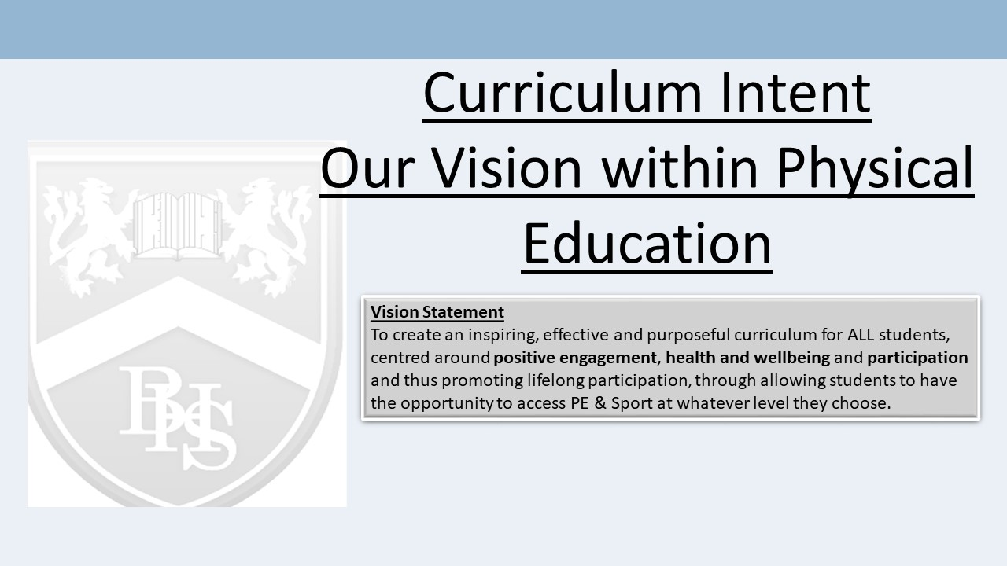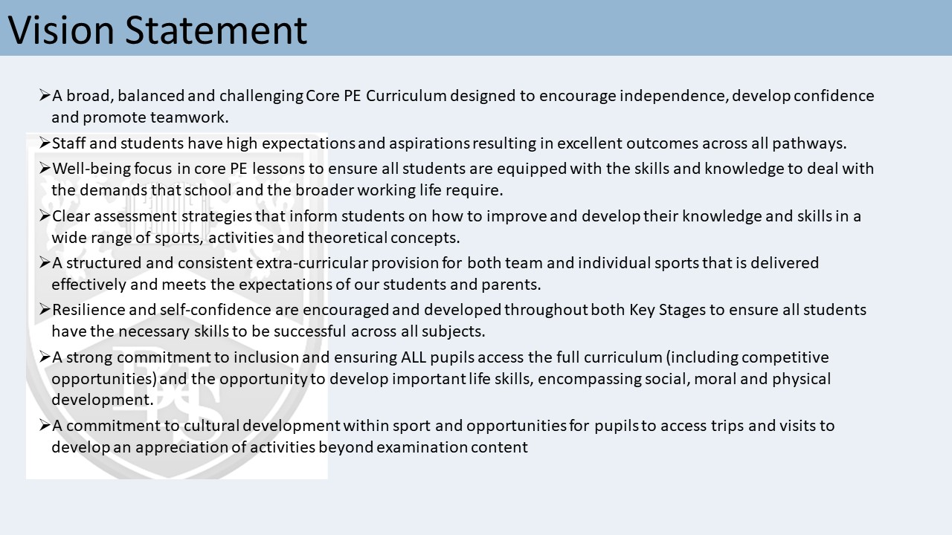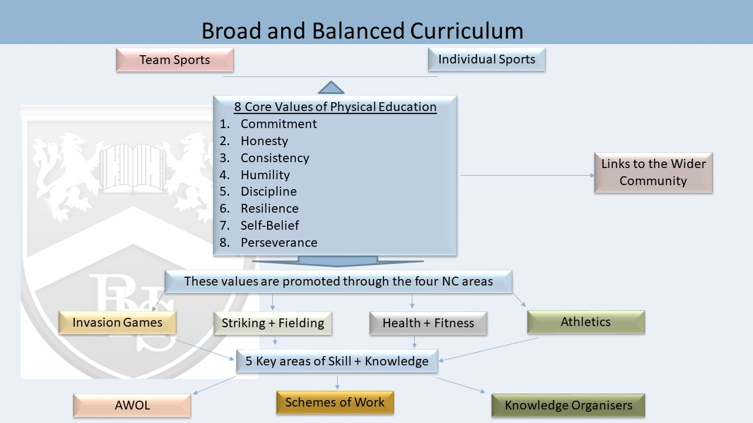

Bridgewater Curriculum Intent - PE

The fundamental aim of the Physical Education Faculty is to create an inspiring, effective and purposeful curriculum for ALL students, centred around positive engagement, health and wellbeing and participation.

We believe in providing students with a challenging, stimulating and safe environment for high quality teaching and learning which is achieved through an enjoyable and productive atmosphere for both staff and students.

Through regular participation in Physical Activity, students are expected to develop character, confidence, resilience and independence, enabling students to make informed choices for lifelong engagement in Physical Activity.

We believe that all students should have the opportunity to participate in PE & Sport at whatever level they choose whether that be just through core PE lessons at Key Stages 3 and 4 or indeed through qualification subjects at Key Stage 4. This is achieved through a broad and balanced curriculum which allows for the acquisition and application of vital transferrable skills appropriate to a range of sporting activities.

Furthermore, we recognise the need for a structured and consistent extra-curricular programme for both team sports and individual sports and pride ourselves on the competitive opportunities that our pupils are presented with both inside and outside of the curriculum.
To enable this to happen our curriculum in planned around the following 6 dimensions:
- Clarity around the sequence of learning over 5 years.
- Clarity around the knowledge and the application of knowledge.
- Vocab and literacy
- Subject content which is Aspiring, Inspiring and ‘Real World Learning'
- Memory and Cognition.
- Assessment. Clarity around the end points and the assessment of what students know and can do.

Six Dimensions of the BWH Curriculum
- Clarity around the sequence of learning over 5 years
Knowing and understanding more at each stage of the curriculum.
At Key Stage 3, pupils will cover a wide range of sports and activities which are delivered under 4 key areas;
Invasion Games, Striking and Fielding Activities, Athletics and Health and Fitness. Pupils visit each theme in Years 7,8 and 9 with links made to previous learning within the specific sports that are covered. At Key Stage 3 the focus is on the development of key skills both in a practical setting and in the development of social and thinking skills, thus supporting the Personal Development aspect of the whole school priorities. At Key Stage 4 Core PE, pupils continue to cover a wide range of activities although there is a greater focus on the application of skills and knowledge through conditioned games. The KS4 Core PE curriculum addresses the barriers to pupil dropout rates in sport and as such there is a more flexible and participation based approach to support the ethos of encouraging lifelong participation.

Many pupils select GCSE PE as an option which builds upon the practical and theoretical knowledge gained through the Key Stage 3 Curriculum. The course content is taught in line with the specification which is designed to allow students to retain knowledge and make links to their learning.

- Clarity around the knowledge and the application of knowledge
Explicit teaching of subject knowledge and relevant background knowledge that can be applied to problem solving and is transferable between contexts and subjects.

At Key Stage 3 and 4 Core PE, pupils follow schemes of work which set out the key skills/objectives that need to be taught. Opportunities are used within the start of lessons to review previous learning and recall content to assess that skills and knowledge have been understood before new content is delivered.

Whilst the majority of the focus is on the execution of the physical skills, pupils are also expected to apply their tactical understanding to a wide range of situations within different sports; many of which are transferable between the activities covered. Each of the 4 key themes (Invasion Games, Striking and Fielding Activities, Athletics and Health and Fitness) are supported by an overview of the unit which explicitly sets out what technical and social skills students will be taught at Key Stage 3.

The Health and Fitness Unit of Work provides an opportunity for pupils to develop a knowledge and understanding of the importance of a wide range of theoretical concepts. This supports the transition from the Key Stage 3 Curriculum to the examination subjects at Key Stage 4 whilst also equipping pupils with the necessary skills to be successful across all subjects.

The GCSE PE qualification is supported through knowledge organisers which set out the key concepts to be taught. These form the basis of lesson starters, using low stakes quizzes and targeted questioning to ensure pupils are able to retrieve and recall key subject knowledge.

- Vocab and Literacy
Vocabulary: Explicit teaching of vocabulary at all stages of a subject.

For each unit of work/activity covered in Core PE, there is key vocabulary to be taught and pupils are expected to understand the key terminology and command words to improve cognition. Unit overview’s for each activity explicitly state the key terminology needed. Pupils are encouraged to develop their spoken literacy through responding to questioning and through smaller group work. In Key Stage 4 examination subjects, knowledge organisers, schemes of work and individual lesson resources explicitly state the key vocabulary that is needed to be successful. This is supported through the Glossary of Terms which pupils are expected to know, understand and apply in the correct format.
At a whole school level the use of Lexonics is used to enable students to employ and transfer meaning across subjects.
- Subject content which is Aspiring, Inspiring and ‘Real World Learning'

The PE Curriculum is designed to ensure that ALL pupils have opportunity to experience a wide range of sports and activities with a view to promoting lifelong participation. Lessons are taught in an environment that actively encourages learning and enthuses pupils, encouraging pupils to extend their involvement in PE and Sport beyond the curriculum. There is a strong emphasis on the well-being of our pupils and PE plays a leading role in supporting the Personal Development of students through encouraging independence, confidence and resilience to allow students to be successful across all subjects.

Timetabled PE lessons are supported by a structured and consistent extra-curricular programme which is led by a range of PE Staff, Non Specialist PE Staff, and External Coaches and supported through strong links with community clubs. Pupils are actively encouraged to engage in additional sporting opportunities and many pupils do.

The PE department have a strong commitment to providing competitive opportunities for all pupils both within and outside of the curriculum. The school is immensely proud of the success it brings across a wide range of sports and activities which is shared regularly amongst the pupils, staff and the wider community. Individual successes are also celebrated and sport is given a high profile within the school.

The PE Faculty show a strong commitment to cultural development within sport and regularly provide opportunities for pupils to access trips and visits. Examples include Sports Tours, Sporting Experiences (Wimbledon/Professional Matches) and activities to support the examination Content (Rock Climbing).

- Memory and Cognition

At Key Stage 3, pupils revisit sports and activities and as such are able to recall the key skills and knowledge learnt. Schemes of work are written to revisit key concepts and assess whether knowledge has been consolidated before new content is taught. PE staff will routinely use the start of lessons to support retrieval through targeted questioning, demonstration of practical skills and drawing links between previously learnt work.
Examination subjects at Key Stage 4 make use of knowledge organisers to encourage retrieval through low stakes questioning and quizzes at the start of lessons. Spaced retrieval strategies support this concept with interleaved topics assessed.
Throughout the two years, pupils are supported in their approach to preparing for examination content and are encouraged to use a range of revision strategies to manage their cognitive load. Use of Mnemonics is routinely used within theoretical PE work and supports pupils in their retention of key concepts.

- Assessment: Desired outcomes and how they are measured.
The assessment of Core PE at Key Stages 3 and 4 includes both formative and summative judgements. Pupils are assessed through demonstration of practical skills and the use of targeted questioning to assess their knowledge and check for understanding. Such methods are used to address any misconceptions and inform future lesson planning. AWOL criteria is used at Key Stage 3 to assess pupils overall ability within each unit of work and pupils are actively encouraged to self and peer assess regularly.

In GCSE PE, pupils are assessed regularly through targeted questioning, low stakes retrieval quizzes and specific examination questions for each topic. There are also a range of more formal assessment opportunities which are provided through the QMA cycle, end of unit tests and mock examinations in both Years 10 and 11. These methods are used to fully assess the pupil’s ability to apply their knowledge and skills.

Assessment as Bridgewater aims to:
i) Promotion of Learning
ii) Informs teaching
iii) Is both formative and summative
iv) Recognises student progress and achievement

Class Level.
At class level students are assessed through the following strategies:
- Daily recap quizzing
- Targeted questioning. (no hands up)
- Hinge questions
- Low stakes testing
- Peer to peer quizzing
- Self-quizzing
- Multiple choice questions
- Quality Mark Assessment (Application tasks)

School Level
Whole school/year assessment points are planned as the best fit to support learning, in a manner which is year group specific. Whole school assessment is not tail wags the curriculum dog.
KS4 Formal standardised pre-public exams twice a year.
KS3 Formal examination style testing based on retrieval of information throughout the key stage.

