Bridgewater High KS3 Science Y9

Mastery booklet: Biology 9 Genetics

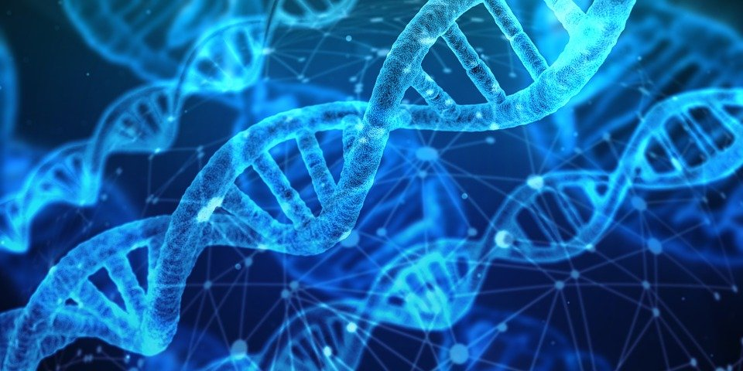

Lesson | Core ideas | Learning outcomes | R | A | G
1 Variation | Variation can be caused by inheriting different genes or through the influence of factors in our environment. | - To recall that offspring have similar but not identical characteristics  - Be able to describe some characteristics that are passed on via genes, the environment or both.  - Explain how characteristics can be a benefit or be harmful to an organism.
2 DNA, genes and chromosomes | Know that genes consist of the chemical we know as DNA | - To be able to correctly use keywords; nucleus, chromosomes, genes, DNA  - Describe the relationship between genes, chromosomes, DNA and proteins  - To be able to name the people who discovered DNA and explain why this discovery was so important.
3 Inheritance | To understand the role of a gene | - Be able to define genetic terminology to include: Allele; Gene; Heterozygous and Homozygous; Genotype; Phenotype
4 Selective breeding | The process of selective breeding | - State what selective breeding is  - Describe the process of selective breeding  - Outline the pros and cons of selective breeding
5 Cloning | What a clone is and how cloning is done? | - State what a clone is and give examples of clones that have been made.  - Describe how mammals can be cloned to produced exact genetic copies.  - Explain why mammals may be cloned and the arguments for and against cloning.
6 Genetic engineering | Genetic engineering is a process which involves modifying the genome of an organism by introducing a gene from another organism to give a desired characteristic. | - Genetic engineering is a process which involves modifying the genome of an organism by introducing a gene from another organism to give a desired characteristic  - Describe the advantages and disadvantages of modifying genes.  - Explain how genes are modified

Lesson 1: Variation
Lesson Key Words
Environment Characteristics Variation

RETRIEVAL AND WCSI/WPS
Core ideas- Reading, models, activities
Core activity: What do we already know?
Quick quiz.
Reading
Tigers and an octopus look very different. They are clearly different species. Lions and tigers however are more similar, but both are still quite different. They are clearly both cats, but they are different species of cat. If we got two tigers, they would both look different too, but they would be the same species. A species is defined as a group of organisms that are similar enough that they can reproduce with each other and produce fertile offspring. Fertile offspring are organisms that can themselves go on to have offspring of their own. Lions and tigers can breed with each other, but the offspring are infertile because they do not have functioning reproductive systems.
Members of the same species are all similar but do show differences. Humans are a species, and each of us looks different – eye colour, height and shoe size are all examples of the differences between individuals. Even identical twins have different fingerprints! The scientific term for these differences is “variation”.
Core activity: Watch Story of inheritance
Story of inheritance – video questions (Answer in your books)
- What did Aristotle say about why children looked like their parents?
- What did Neil Stenson discover?
- What di Antoni van Leeuwenhoek discover?
- What did people think developing babies started life like?
- For how long did the “spermists” and “ovists” debate their own theories?
- What did Robert Bakewell do in the 1800s?
- Who bred pea plants? Where did this happen?
- What did Francis Gorton investigate and who was his famous relative?
- When was the term ‘gene’ created?
- What did Thomas Morgan show?
- What did Watson and Crick discover?
- So how do we now describe genes?
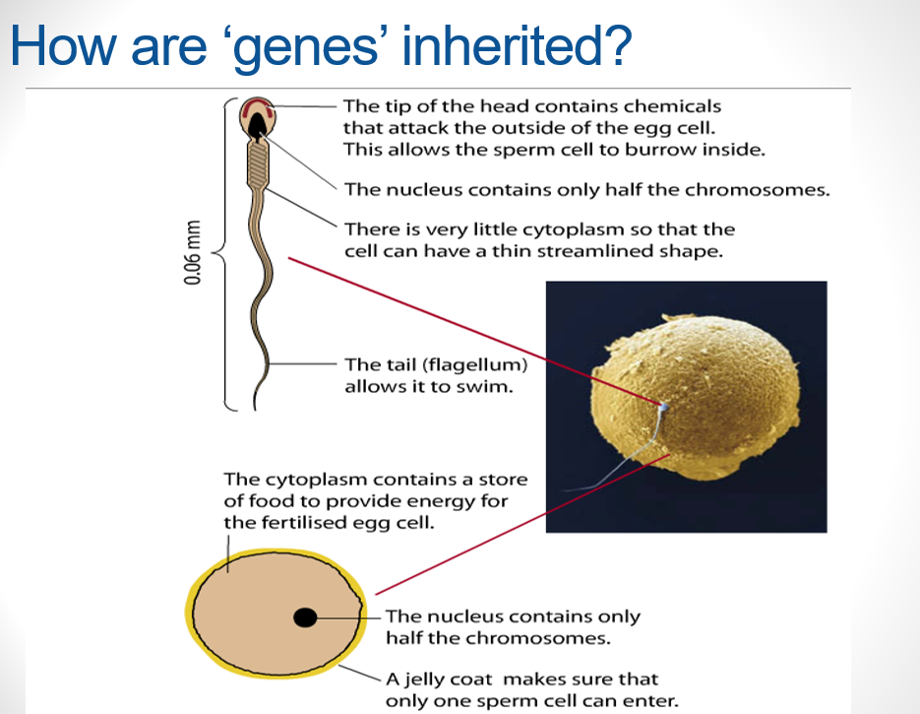

Core activity: Class practical: Measuring and recording human variation

COPY THE TABLE INTO YOUR BOOK
Student | Height/cm | Head circumference/cm | Eye colour | Hand span/cm | Arm span/cm
1
2
3
4
5
6
7
8
9
10
Largest/Smallest
Mean

- Calculate mean results
- Choose how to graphically display two of the variations measured

Reading
Variation is grouped into two types:
Continuous variation and
Discontinuous variation.
Continuous variation is for things like height, weight or hand span. They are characteristics that change gradually over a range of values, and the value could fall anywhere within a range. Continuous variation is usually caused by both inheritance and your environment.
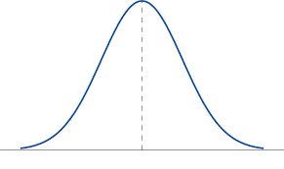
A graph of continuous variation often has this classic shape known as a bell curve.

Discontinuous variation is for things like blood group, sex (male or female) or ability to roll your tongue. These variations take one of only a limited number of possible values. Discontinuous variation is usually only caused by inheritance.
Application questions
- Describe the differences between continuous and discontinuous variation.
- What causes continuous variation?
- The same group of people above had their blood group recorded. Draw a bar graph of the data table below.
Blood group | Number of people in category
A | 78
B | 7
AB | 19
O | 82

- What causes discontinuous variation?
- For each of the following, identify if it is continuous or discontinuous variation.
- How deep into the ground the roots of a cactus go.
- Peppered moths can either be light in colour, or dark in colour.
- Snap dragon petals can be red, white or pink.
- How much milk a cow can produce in litres.
- Hand span (this is a measure of the distance between the tip of someone’s little finger and their thumb, when their hand is stretched out).
- Length of giraffe necks.
- The colour of a jelly baby.

Lesson 2 - DNA, genes and chromosomes
Lesson Key Words
DNA – Deoxyribonucleic acid chromosome precipitate

RETRIEVAL AND WCSI/WPS
Core ideas- Reading, models, activities
Core activity: Working scientifically Extraction of DNA from strawberries
Follow worksheet (9b1) Fruit DNA extraction

Reading
Genetic information is passed from one generation to the next. This is called heredity and why we resemble our parents. The genetic information itself is contained in a complex molecule called DNA.
DNA
- DNA stands for deoxyribonucleic acid. It is made up of two long molecules. The molecules are arranged in a spiral, like a twisted ladder. We call this the double helix structure.
- There is DNA in the nucleus of every cell. DNA carries genetic information. It has all the instructions that a living organism needs to grow, reproduce and function.
Genes
- Genes are short sections of DNA. Genes carry information for particular characteristics, such as ear shape or eye colour. Different sets of genes carry information for different characteristics. There are many genes in a chromosome.

Chromosomes
- In a cell nucleus, DNA is organised into coiled strands called chromosomes.
- Humans have 46 chromosomes in each body cell. The fruit fly has only 8 chromosomes and is often used to study patterns of inheritance, while red king crabs have a whopping 208!
- Half the chromosomes are inherited from one parent and half from the other.
- Human gametes (eggs and sperm) each contain 23 chromosomes. When an egg is fertilised by a sperm, it becomes a cell with 23 pairs of chromosomes.
- This is why children resemble both their parents – half of their chromosomes and DNA come from their mother, and half from their father.
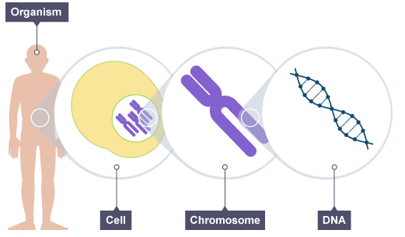
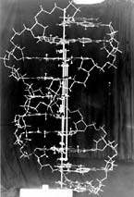

X-ray diffraction’ images of DNA
Watson & Crick’s ball and stick model

Scientists worked out the structure of DNA in the 1950s. Rosalind Franklin first made ‘X-ray diffraction’ images of DNA.
James Watson and Francis Crick used information from one of her images to work out a model for the structure of DNA.
Watson and Crick were able to work out how DNA was arranged and the tiny distances between its different features. They worked out that in a DNA molecule:
- there are two strands
- the strands are twisted around each other to form a double helix
- the strands are held together by bonds between base pairs
- Base pairs are formed by nucleotides joining together, C always joins to C and A to T
- Watson, Crick and Wilkins were awarded the 1962 Nobel Prize in Physiology or Medicine for their discovery.

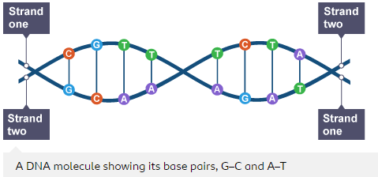

Core questions
- Label the diagram: Nucleus, Chromosome, Gene, DNA
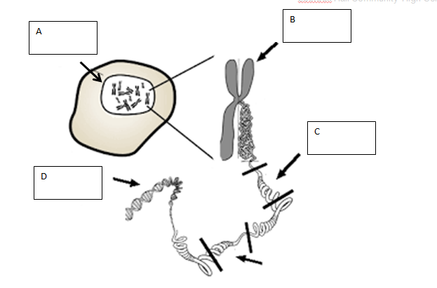

- Where do we find all our DNA?
- What is a chromosome?
- How many chromosomes are in an adult human cell?
- How many chromosomes are in an egg/sperm cell?
- What has happened to the chromosome number?
- Why is it important that this happens?
- Sheep have 54 chromosomes. How many will be in each sex cell?
- All organisms have an even number of chromosomes in their body cells. Why is this?

- Most cells contain two sets of chromosomes which can be sorted into pairs. Some chromosomes are bigger than others and so the pairs can be arranged in size order, apart from the last two. The picture shows human chromosomes from a cheek cell.
- Three of the chromosomes are missing. Draw in the missing ones on the diagram.
- Where in a cell would you find the chromosomes?
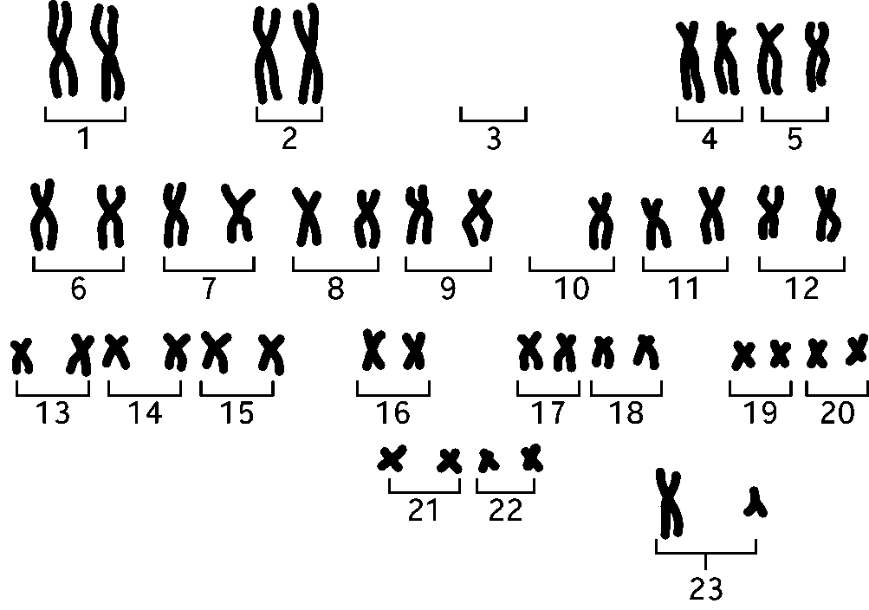
- Chromosomes are divided into sections called genes. Each of the chromosomes labelled number ‘22’ contain about 100 genes. Would you expect to find more, less or the same number of genes in a chromosome like number ‘1’?
- Explain your answer to number 2.
- What do genes do?

Application questions

- Look at the bar chart.
- How many chromosomes does a body cell in a cat have?
- Which species has 66 chromosomes in its cells?
- On the chart, fill in the missing bar for humans. Wolverine 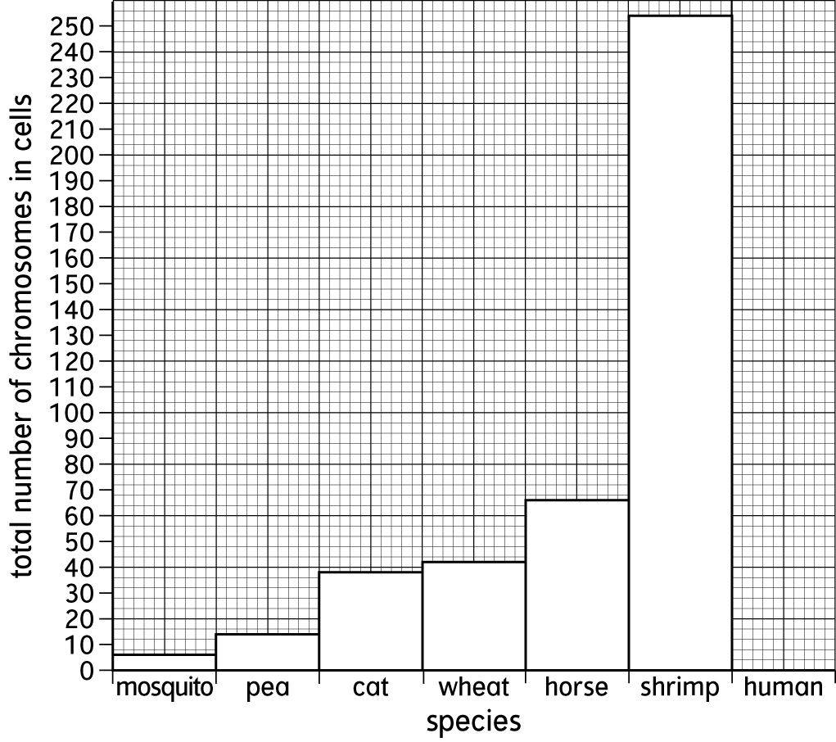
Numbers of chromosomes in the body cells of different species.

- Why do you think that the total number of chromosomes in the cells of each species is an even number?
- Do you think there is a relationship (pattern) between the number of chromosomes in the cells and the size of the organism?
- John said “If you look more like one parent than another it is because you have more of their genes”. Is he correct? Give a reason.
- A sperm cell image measures 20mm on a microscope slide at x400 magnification. What is it’s actual size? (Actual = Image / magnification)

Lesson 2b – Literacy HeLa cells

Lesson 3 – Inheritance -

Lesson Key Words
Allele homozygous heterozygous genotype phenotype gamete

RETRIEVAL AND WCSI/WPS

Core ideas- Reading, models, activities
Core activity: Bitesize clip: https://www.bbc.com/bitesize/guides/zqv6gdm/revision/1

Reading
- For each genetically controlled characteristic we have two genes – one from each parent.
- Different versions of the same gene are known as alleles - e.g. the hair colour gene has 4 alleles – black, brown, blonde and red.
- Some alleles are ‘stronger’ than others and will always show in the individual’s characteristics. These are known as dominant alleles, and we represent them using capital letters – e.g the allele for brown hair is dominant (B), so a person with even only one B will have brown hair.
- Weaker alleles are known as recessive, and will only be expressed if there is not a dominant allele. We use lower case letters to represent them – e.g. the allele for blonde hair is recessive (b)
- The pair of alleles for a particular characteristic can be the same or could be different. If the two alleles are the same (e.g. BB), the person is said to be homozygous for that trait.
- If the two alleles are different (Bb), the person is said to be heterozygous.
- The pair of alleles is known as the genotype. The characteristics shown because of the allele combination is the phenotype.
E.g – (Bb) the genotype is heterozygous, the phenotype is brown hair.
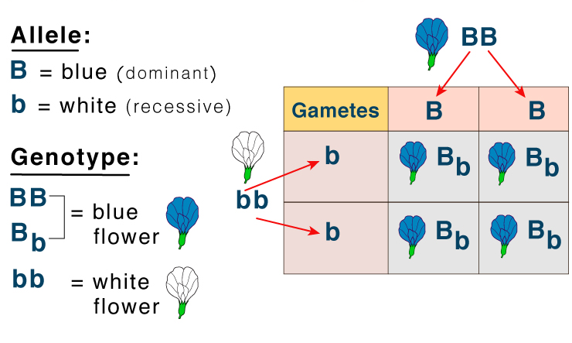

Core questions

- What is an allele?
- Why do we have at least 2 genes for every characteristic?
- What does homozygous mean?
- What is the ‘genotype’ of a person?
- What is the ‘phenotype’?
- The drawings show identical twins, Sara and Helen and their parents.

        - 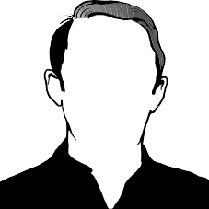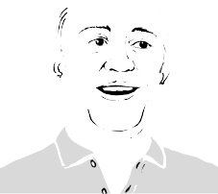

        - 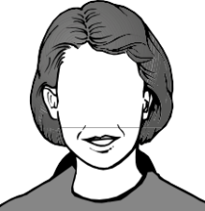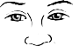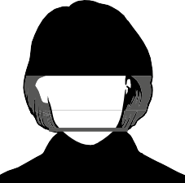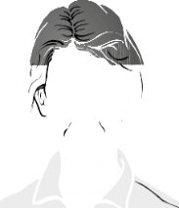

    - Sara and Helen have brown hair like their father and blue eyes like their mother.
    - Why do children have characteristics of both parents?
- Sara and Helen are identical twins. Why do they have identical characteristics?
- Sara now spends a lot of her time working outdoors in a hot country. Helen now works in an office in England. Complete the table.
Characteristic | Is it identical for Sara and Helen?
eye colour
skin colour
weight

- Neither Helen nor Sara have blond hair like their mother – they have both brown hair like their father. Explain why, even though they have inherited a gene for hair colour from their parents.
Application questions

Genes that carry different genetic information about the same characteristic (e.g. eye colour) are called alleles (pronounced ‘al-leels’). Some alleles are dominant, which means that they will stop other alleles (called recessive alleles) from having any effect. A dominant allele is written with a capital letter and a recessive allele has a small version of that capital letter.

The Marvel family have a secret … some of them are superheroes with enormous strength. The super-strength is caused by a dominant allele.
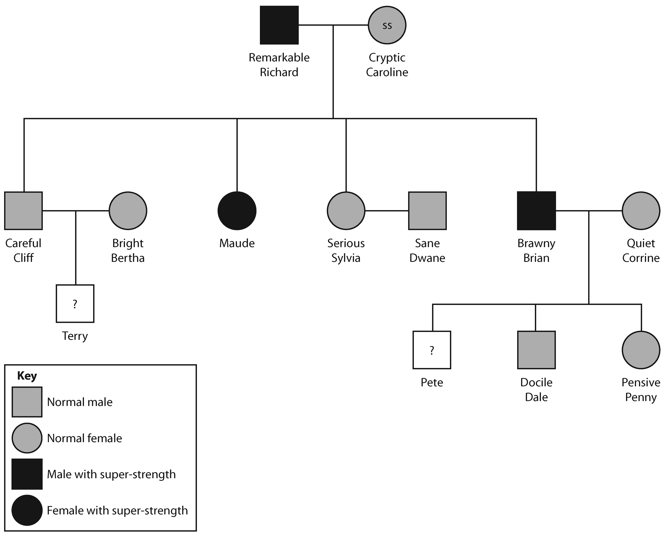

47. Using S to represent the dominant allele and s to represent the normal allele, show what alleles Remarkable Richard has. Explain your reasoning.
48. Suggest a full name for Maude. Explain your choice.
49. What alleles does Brawny Brian have? Explain your reasoning.
50. What chance is there that Terry also has super-strength? Give your answer as a percentage.
51. What chance is there that Pete also has super-strength? Give your answer as a percentage.
52. Most people are not superheroes. Describe the factors that allow some non-superhero people to be stronger than others.

Lesson 4 Selective breeding
Lesson Key Words
breeding, clone, cloning, cross-breeding, selective breeding

RETRIEVAL AND WCSI/WPS
Core ideas- Reading, models, activities
Reading
Humans can speed up evolution by the process of selective breeding (artificial selection). It is the process by which humans breed plants and animals for desired characteristics. Here is a list of desired characteristics (and quite often the advantages to selective breeding):
- Disease resistance
- Increased food production/crop yield
- Gentle nature of domestic animals (eg. Dogs)
- Heavily scented flowers

It is especially useful in agriculture, where farmers want all or most of their animals or plants to be resistant to diseases and can grow in size quickly, so they could farm and harvest as efficiently as possible for profit.

- Copy the lists below and match up the animal/plant with what you would expect would be selectively bred for

This is the process of selective breeding:
- Choose two individuals with the desired characteristic(s) from a mixed population.
- Allow them to breed, which produces offspring with a range of characteristics.
- Choose the few offspring with the (most) desired trait(s) and allow them to breed.
- Repeat this cross-breeding process over many generations until all the offspring show the desired characteristic.
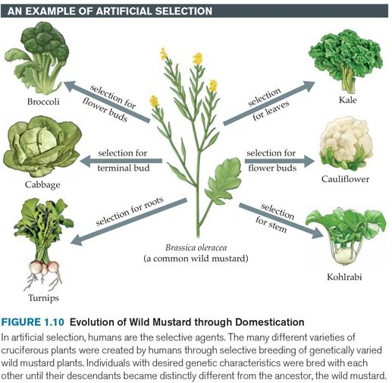

Here are pros and cons to selective breeding.
Advantages | Disadvantages
Disease resistance in food crops | Reduces genetic variation (lose allele variation) 🡪 less likely to be able to cope with major environmental changes 🡪 die out
Animals which produce more meat or milk | Inbreeding more prone to certain diseases/inherited conditions  (more likely to inherit homozygous recessive alleles recessive genetic disorders)

Domestic dogs with a gentle nature

Large or unusual flowers

Core questions
- Define ‘selective breeding’.
- What are the desired characteristics in farm animals? Explain.
- Describe the process of selective breeding.
- Name two historic examples of selective breeding.
- State four modern examples of selective breeding.
- How do breeders of domestic pets use selective breeding to produce many pets?

Look at this list of characteristics of tomato plants.
Big tomatoes. Plants are resistant to disease.
Plants will not die in temperatures below 4°C. Tomatoes are juicy.
Plants produce lots of tomatoes. Tomatoes are very tasty.
Tomatoes are bright red. Tomatoes grow in clumps of four.
Tomatoes stay fresh for 6 days. Small leaves.
54. Draw a table to show whether each of these characteristics can or cannot be seen when you look at the plants.
55. List the three characteristics that you think are the most important to shoppers in a supermarket. Explain your choices.
56. List the three characteristics that you think are the most important to farmers. Explain your choices.
57. Imagine you are a plant breeder. Write down three characteristics from the list that you would like your new variety of tomatoes to have. Explain your choices.
58.To breed plants a plant breeder takes pollen grains from one flower and puts them onto the stigma of another. Is this pollination or fertilisation?
59. Are the pollen grains the male or the female sex cells?
60 Once on the stigma, a pollen grain grows a tube down towards an egg cell which is contained in an ovule. The nucleus from the pollen grain goes into the egg cell. Is this pollination or fertilisation?

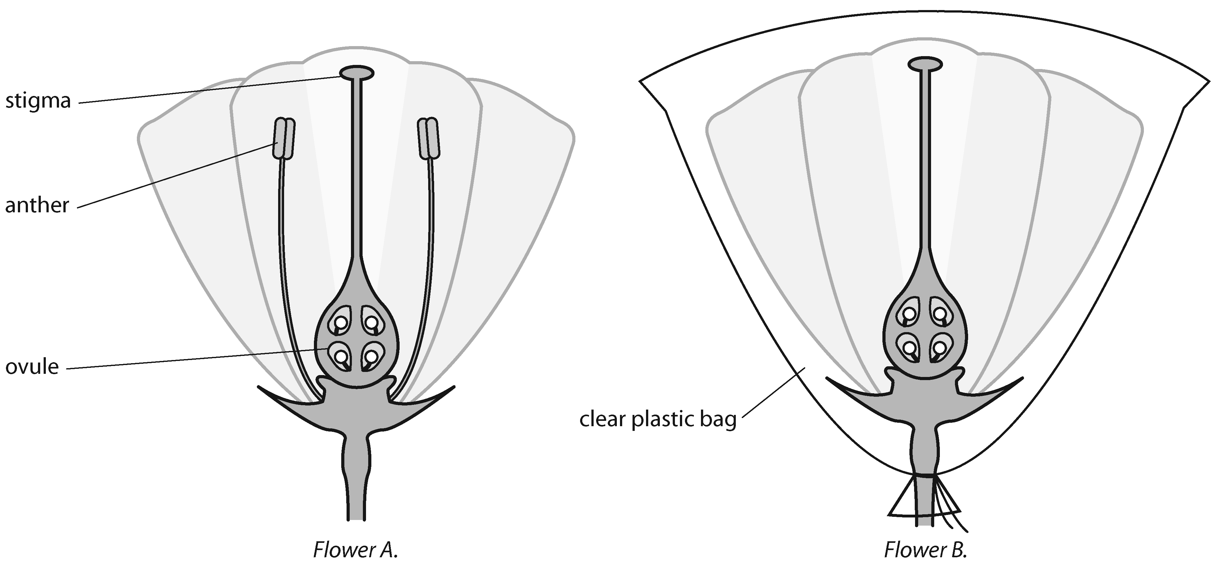
61. The drawings show two flowers. Flower A is a normal flower and flower B has had pollen added to its stigma by a plant breeder.

Flower A. Flower B.
61. The breeder has put a plastic bag around the flower. Suggest why.
62. The anthers have been removed. These make pollen grains. Suggest why removing them is a good idea.

Application questions
- Explain how selective breeding reduces genetic variation.
- Explain how selective breeding can lead to extinction of a species.
- State another problem with selective breeding and explain why that is a problem.

Lesson 5 Cloning
Lesson Key Words
breeding, clone, cloning, asexual

RETRIEVAL AND WCSI/WPS
Core ideas- Reading, models, activities
Reading
A clone is an individual that has been produced through asexual reproduction and is genetically identical to the parent. Clones can be made by different methods, also dependent on if you are trying to clone plants or animals.

Method – Adult cell cloning ( eg dolly the sheep)

- Extract an adult body cell and an unfertilised egg cell (from different individuals)
- Remove the nucleus in the egg cell
- Extract the nucleus from the adult body cell and insert it into the empty egg cell
- Pass a small electric shock through to the egg cell, stimulating it to start dividing to form an embryo
- Insert the embryo into an adult female to continue its development into a fetus
- The offspring is genetically identical to the nucleus donor (ie. The donor of the adult body cell)

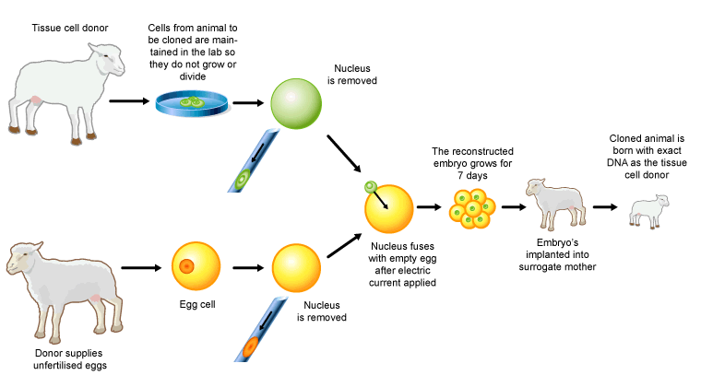

Cloning plants
Method 1 Cuttings ( demo)
Plant cuttings can be dipped in hormone rooting powder before planting
The simplest way to clone a plant is to take a cutting:
- cut off a branch from the parent plant
- remove the lower leaves and plant the stem in damp compost
- plant hormones in rooting powder can be used to encourage new roots to develop
- cover the cutting in a clear plastic bag to keep it moist and warm

Method 2 Tissue Culturing
Tissue culture is another artificial way to clone plants.
It uses tiny pieces from the parent plant, rather than cuttings.
Sterile agar jelly with plant hormones and lots of nutrients are needed.
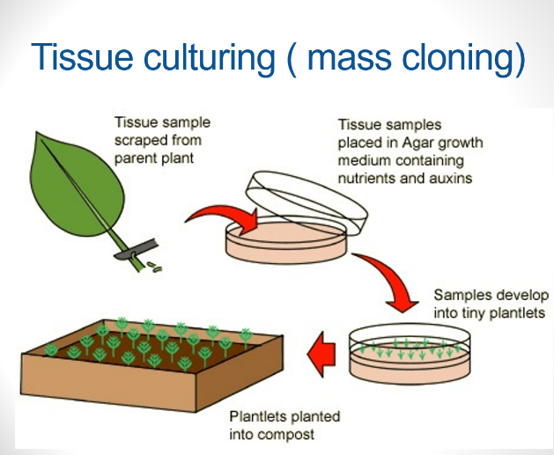
Tissue culture is more expensive and more difficult than taking cuttings.

Some pros and cons of cloning:

Advantages | Disadvantages
Combine with genetic engineering to increase crop yield | Reduce genetic variety/Smaller gene pool  🡪 less likely to survive in changing environment
Save animals from extinction | Potential use in engineering human babies (ethical concerns)

Core questions

- Define ‘clone’.
- Name the traditional method of artificial plant cloning.
- Name the modern method of artificial plant cloning.
- What are “plant cuttings”?
- Describe the process of modern artificial plant cloning.
- Compare the offspring from embryo transplants with each other and with the parents.
- Explain why artificial plant cloning is useful.

- Explain what a farmer would do to breed cows that produce more milk than cows already on the farm?
- A farmer has a cow that produces an enormous amount of milk. The farmer wants to increase the numbers of cows with this characteristic very quickly. Explain whether each of the following methods will allow the farmer to do this.
a selective breeding
b cloning

Lesson 6 Genetic engineering
Lesson Key Words
Plasmid modification enzymes genetically modified ( GM) genome

RETRIEVAL AND WCSI/WPS
Core ideas- Reading, models, activities
Reading

Genetic engineering is the process where a gene from an organism is transferred to the genome of another organism to give it a desired characteristic.

Many organisms have been genetically modified (GM) for the benefits of humans, for example, GM crops becoming disease/pest-resistant and make bigger better fruits; GM bacteria producing human insulin to treat diabetes.

Core activity: Cut and stick stages of Genetic engineering

Cut and order then glue the stages of genetic engineering into your exercise books. Use the image on page 19 and the details below to help you.

The process of genetic engineering (for making insulin)

- Extract human DNA from human cell and the plasmid (vector) from bacteria

- Cut out desired gene (eg. Insulin gene) from human DNA using restriction enzyme

- Using the same restriction enzyme, cut the plasmid

- Insert desired gene into plasmid, becoming recombinant DNA

- Put recombinant DNA into bacteria, becoming a transgenic bacteria/organism

- Allow transgenic bacteria to multiply by mitosis. All GM bacteria make human insulin

- Extract human insulin to treat diabetes

Some pros and cons of genetic engineering:

Advantages | Disadvantages
Can mass produce desired proteins/products | Resistant genes could be transferred to natural populations (wildtype) this affects biodiversity
Can modify crops to be resistant to pests/diseases this increases crop yield | Expensive

Core questions

- What is genetic engineering?
- What is the term used to describe organisms that are genetically modified?
- Why is genetic engineering useful?
- Give two examples of vectors used in genetic engineering.
- Give two ways in which genetic engineering is useful in agriculture.

Ethics of genetic technologies

When it comes to evaluating genetic technologies, we need to consider them in terms of four aspects: scientific, economic, social and ethical aspects.

Benefits | Concerns
Increase growth rate of plants and animals | Unsure of long-term effects
Increase food value (eg. Higher yield) | Unsure of effect of eating GM food on human  health
Designed to be resistant to poor environments  (eg. Dry, cold) | Affect wildtype organisms’ chances of survival
Designed to be pest/herbicide-resistant | Ethical concerns of potential human engineering

Application questions

- Explain how genetic engineering is useful in treating diabetes.
- Suggest what genes could be engineered into crops to make them pest-resistant.
- How can genetically modified (GM) crops affect the growth and survival of natural (wildtype) crops/plants?

- Complete the sentences below:
Genetic engineering is useful for society because….
Genetic engineering is useful for society but….
Genetic engineering is useful for society so….

Lesson 7b Literacy Sex determination

