Bridgewater High KS3 Science Y9

Mastery booklet: Chemistry 10 More chemical reactions

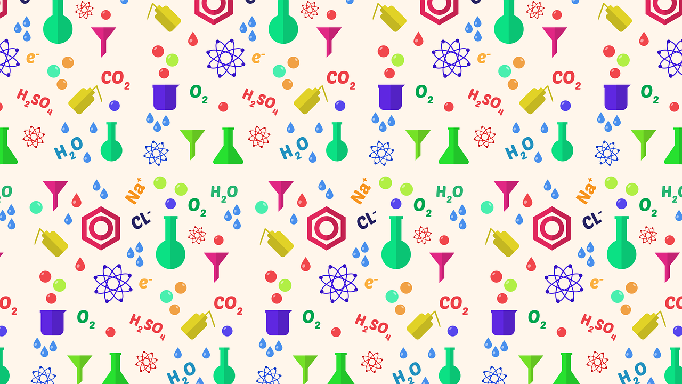

Lesson | Core ideas | Learning outcomes | R | A | G
1 Conservation of mass | Total mass does not change during a chemical reaction | - To recall that some changes are reversible  - To state if a change is chemical or physical  - To state that reactions cause atoms to combine in different ways  - To recall that the mass of the products is the same as the mass of the reactants
2 Conservation of mass 2 | Recognising that total mass can appear to change when a gas is added (e.g. burning) or given off (e.g. decomposition) | - State that chemical reactions cause atoms to combine in a different way  - Recall that the mass of the products of a reaction is the same as the mass of the reactants.  - Explain why mass can appear to change in some reactions
3 Writing equations | Recall reactants (written on left hand side) turn into products (written on right hand side) | - Be able to write word equations to describe chemical reactions.  - To be able to write symbol equations to describe chemical reactions.  - To be able to balance symbol equations.
4 Types of reaction | Total mass does not change during a chemical reaction | - To state that chemical reactions can be used to create new substances  - To state how to identify whether a chemical reaction has taken place  - To name and describe the five different types of chemical reactions
5 Neutralisation | Acid and alkali react to produce a salt and water | - Make and record accurate measurements during a practical  - Recall the definition of neutralisation reactions  - Identify acids, alkalis (bases) and salts
6 Naming salts | Be able to name a salt and write a symbol for it | - Identify bases, salts and acids in neutralisation reactions  - Interpret and write word equations for neutralisation  - Write symbol equations, using given formulae to describe neutralisation reactions  - Balance symbol equations of neutralisation reactions
7 Combustion | Know that carbon dioxide and water are the products of combustion of a fuel | - State that burning most fuels produces carbon dioxide and water  - Recall that fuels burn in oxygen to release energy and this is known as combustion  - Write word equations to show the combustion of specific fuels  - Write balanced symbol equations to show the combustion of specific fuels
8 QMA

Lesson 1 Conservation of Mass
Lesson Key Words
conservation atom mass reactants products reversible irreversible observation reactant product

RETRIEVAL AND WCSI/WPS
Core ideas- Reading, models, activities
Core Activity: Practical
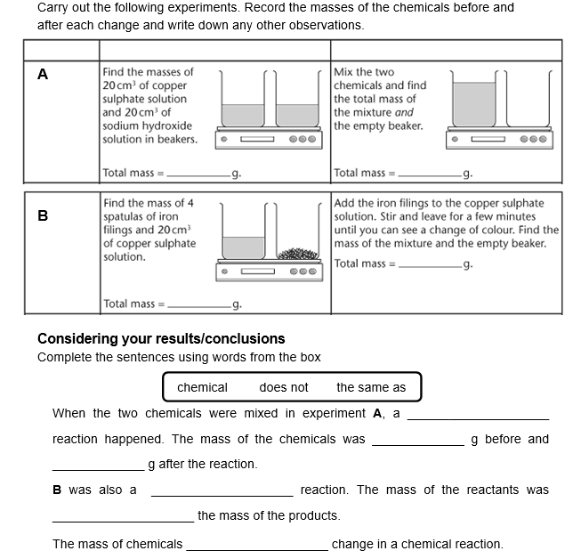

Core Activity: Reading
In our investigations we saw the mass of the reactants was equal to the mass of the products. This is called the conservation of mass
In a chemical reaction, no mass is ever lost or gained. The mass of the chemicals put into the reaction is equal to the mass of the chemicals produced. Sometimes, a gas is given off or a gas from the air is joined with the reactants, so it can seem as though the mass has changed.
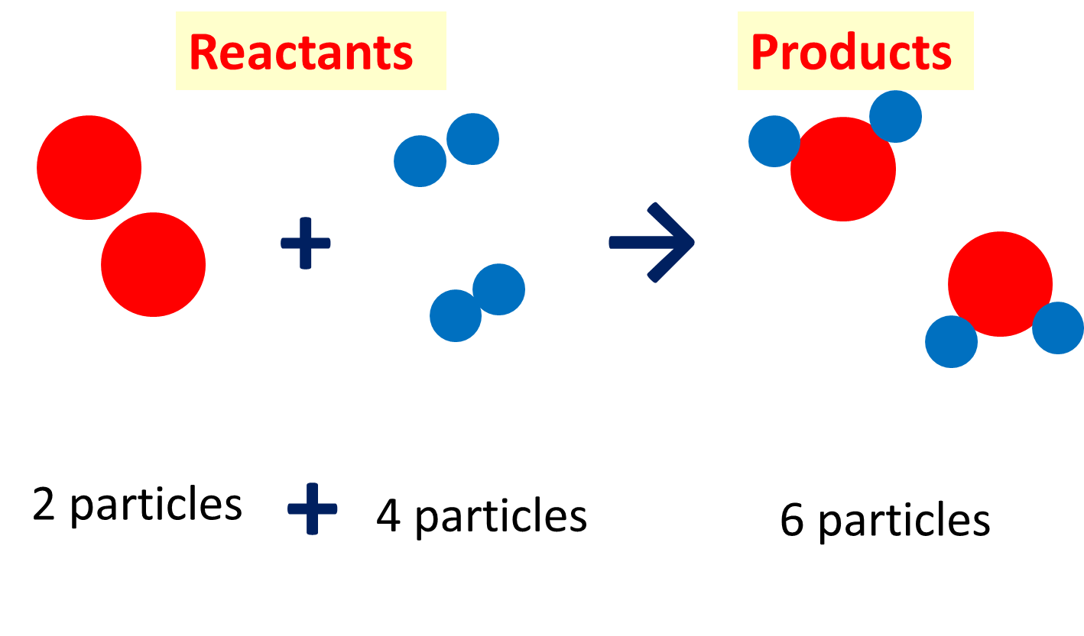
In the reaction above the number and size of the particles has not changed. Just the bonding between them.
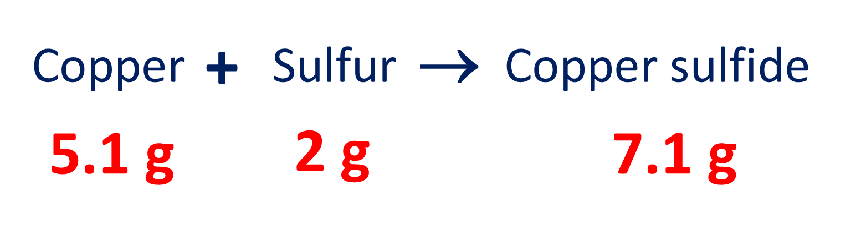
In this example we can see that the total mass of the reactants is equal to the mass of the product

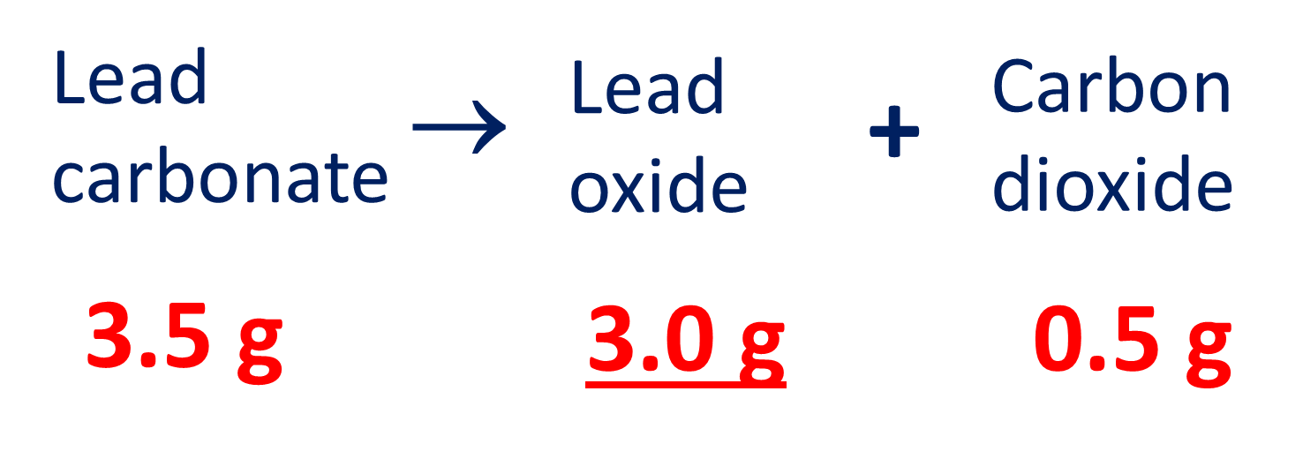
In this example lead carbonate is breaking up into lead oxide and carbon dioxide. When one reactant breaks up into more than one product, we call it a decomposition. Still the conservation of mass is obeyed

Core Questions

- Name 3 things you may observe in a chemical reaction
- Atul reacts 3g of sodium with 2g of oxygen. How much sodium oxide was made?
- Define the law for the conservation of mass
- Longer answer question- describe the differences between a chemical reaction and physical change

Core Activity: Reading
A substance can either be a solid, liquid or gas. Substances can change between these different states of matter and their mass won’t change. Physical changes are different to chemical changes because there is no actual reaction taking place and no new substances are made. The particles stay the same, they just have a different arrangement and the amount of energy.
During a chemical change, there is a reaction taking place and new products being formed – however the atoms have simply been rearranged. When mass appears to be gained or lost, gases are involved. Gases can be produced as a product and would be given off, hence the mass observed would have decreased. Gases can be taken in as a reactant and would be transferred to the products, hence the mass observed would have increased.
Core Question:
- Sort the below statements into the table
- Frying an egg
- Dissolving sugar into water
- Burning magnesium in oxygen
- Reacting iron and sulphur together
- Melting an ice cube
- Puddles drying up
- A candle burning
- Mixing ethanol and water
Chemical change | Physical change

Application question:

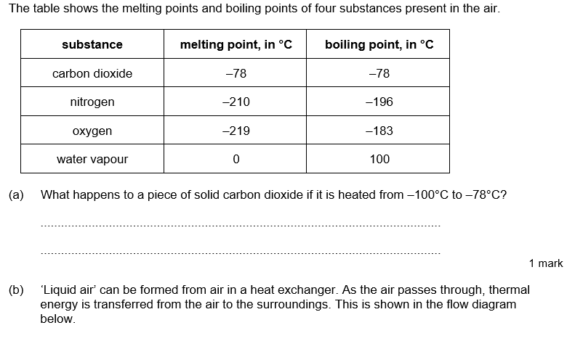
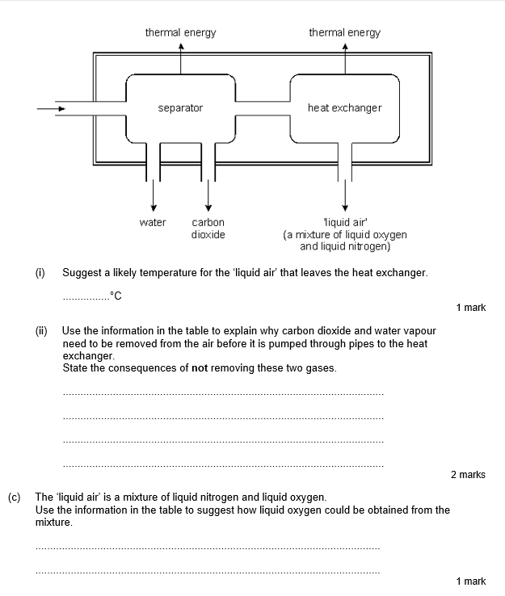

Lesson 2 Conservation of Mass-Part 2
Working scientifically: What happens to the mass of magnesium when it burns?
Lesson Key Words
conservation atom mass reactants products reversible irreversible observation reactant product

RETRIEVAL AND WCSI/WPS
Core ideas- Reading, models, activities
Core Activity: Practical
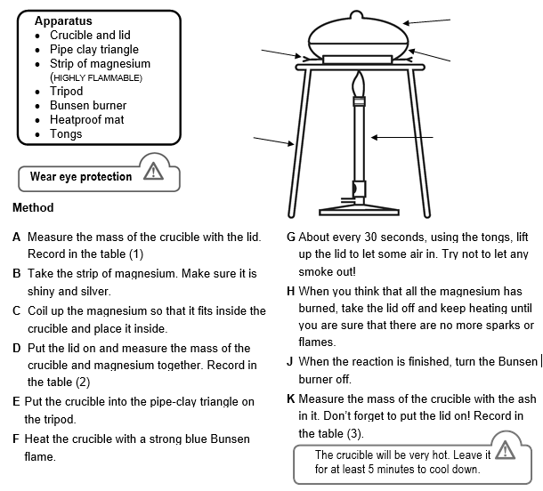
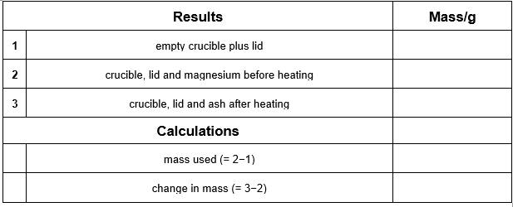
Conclusion: Has the mass changed? Why is this?
________________________________________________________________________________________________________________________________________________________________________________________________________________________________________________________________________________________________________________________________________________________________________________________________________________________________________________________

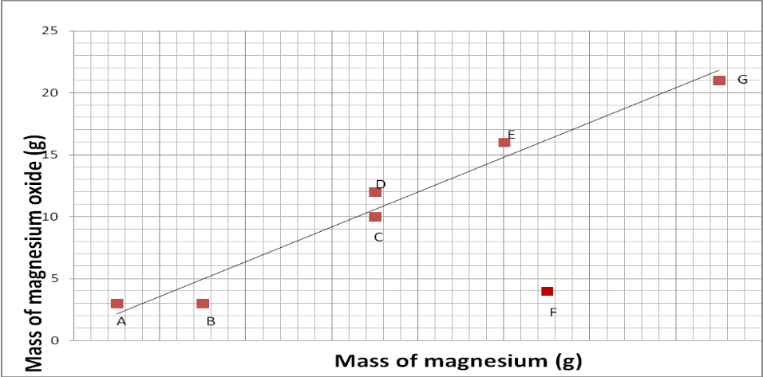
Application question: Interpreting data

- Which group had a strange result?
- What do you think might have caused this?
- Which 2 groups started with the same amount of magnesium?
- What is the general pattern of the results? (Point, Evidence)
- Do the results support the hypothesis?

Lesson 3 Writing equations
Lesson Key Words
conservation atom mass reactants products balanced equation observation reactant product

RETRIEVAL AND WCSI/WPS
Core ideas- Reading, models, activities
Core Activity: Reading
During a chemical reaction substances can react together. These substances are called reactants.
When they react, they form new materials and these are called products.
This can be simplified in a word equation:
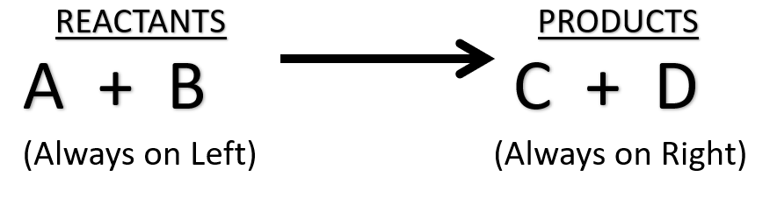

Another key skill in Chemistry is the ability to balance equations. It is important to remember that no atoms are lost or created during a chemical reaction. This means the number of atoms must be the same on both sides of the equation.
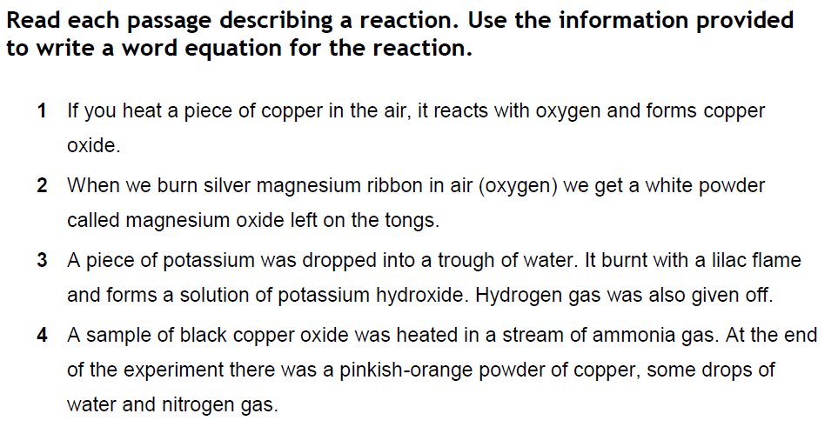
Symbol equations: Worked examples
Na + Cl₂ → NaCl

K + O₂ → K₂O

Core questions:
- Balance the below equations:

- H2 + Br2 HBr
- Ca + O2 CaO
- MgCO3 + HCl MgCl2 + H2O + CO2
- Fe + O2 Fe2O3
- Fe + Cl2 FeCl3
- C2H6 + O2 CO2 + H2O
- K + H2O KOH + H2
- NaNO3 NaNO2 + O2
- CH4 + O2 CO2 + H2O
- Pb(NO3)2 PbO + NO2 + O2

Application questions:

Balance the symbol equations for the reactions below:

a) ____CH₄ + ____O₂ ____CO₂ + ____H₂O

b) ____Mg + ____O₂ ____MgO

c) ____CaCO₃ ____CaO + ____CO₂

d) ____C₆H₁₂O₆ + ____O₂ ____CO₂ + ____H₂O

e) ____Na₂S₂O₃ + ____HCl ____NaCl + ____S + ____SO₂ + ____H₂0

f) ____ LiNO₃ + ____ CaBr₂ ____ Ca(NO₃)₂ + ____ LiBr

Lesson 4 Types of reactions

Lesson Key Words
atom thermal decomposition reactants products balanced equation combustion displacement oxidation reactant product neutralisation

RETRIEVAL AND WCSI/WPS
Core ideas- Reading, models, activities
Core Activity: Reading

Complete combustion
This is when there is an excess of oxygen present. A roaring blue Bunsen flame is an example of complete combustion. As there is more than enough oxygen every single atom of carbon and hydrogen can bond with oxygen. Complete combustion forms carbon dioxide and water. Because so many new bonds are made it releases the most amount of heat. Carbon dioxide is a greenhouse gas and rising levels have been thought to be the main cause of climate change through global warming
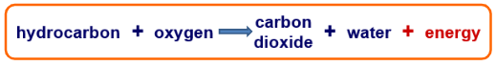

Displacement reactions

A more reactive metal will ‘displace’ a less reactive metal from a solution of its compound. For example – copper sulphate solution contains copper ions. If iron is added, the iron displaces the copper from the solution.
Copper sulphate + iron Iron sulphate + copper
We would physically see a colour change in the solution from a blue colour to a green colour once displacement has taken place as well as a change in colour of the nail with copper forming as a layer on the outside of the nail.

Oxidation reactions are a special type of chemical reaction where a substance reacts with the oxygen in the air. There are many different chemicals which will react with oxygen. The product of an oxidation reaction is called an oxide. A good example is Iron. Iron reacts very slowly to form iron oxide. It turns from a grey shiny metal into an orange brittle substance we call rust. The word equation for the formation of iron oxide would be:
iron + oxygen iron oxide
Remember when writing an equation:
All reactants and products on one line
An arrow is used, NOT an = sign

Core Practical demo: To find out if magnesium reacts with oxygen

Diagram of magnesium before- add labels | Diagram of magnesium after heating- add labels

Core questions
- What happened to the magnesium, why?
- Write an equation for this- label the reactants and products
- Add a particle diagram to show how the particles rearrange
- For the questions below complete the missing names of the substances and add in the missing masses. (hint: remember the conservation of mass)
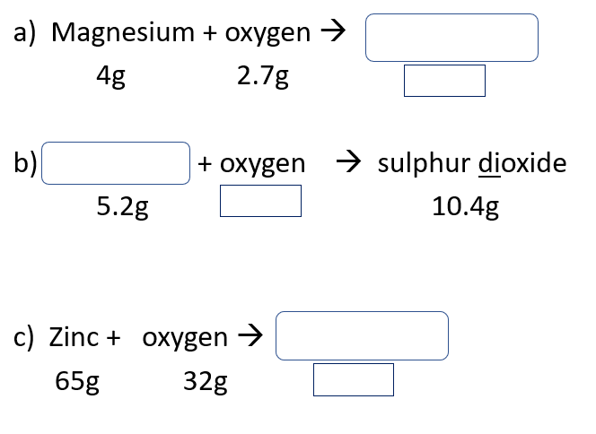

Thermal decomposition reactions:

‘Thermal’ means heat. ‘Decomposition’ means breaking down. Thermal decomposition means the breaking down of a reactant using heat. Metal carbonates often undergo thermal decomposition to form a metal oxide and carbon dioxide.
For example:
calcium carbonate calcium oxide + carbon dioxide
CaCO3 (s) CaO (s) + CO2(g)​

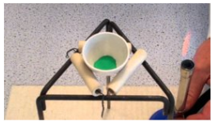
Practical demo: Decomposition of copper carbonate.
- Weigh the empty crucible – record this mass​ in a table of your own design
- Add two spatulas of copper carbonate and reweigh. ​
- Sit it on a tripod and clay pipe triangle and heat with a roaring flame until the reaction is over. ​

While the reaction completes, calculate the mass of copper carbonate you started with​.
- Reweigh your crucible. ​
- Calculate the mass of copper oxide in the crucible. ​
- What mass of carbon dioxide must have been given off? ​
- ​Write the equation for the reaction and the masses you’ve worked out underneath each substance. ​
Core questions
As a gas is a product of the reaction there is an apparent loss of mass during the reaction.

- Define ‘thermal decomposition’
- Why is a thermal decomposition an endothermic reaction?
- State the law for the conservation of mass
- What causes there to seem to be a drop-in mass?
- Write word equations for the following thermal decompositions:
  - Magnesium carbonate
  - Zinc carbonate
  - Copper carbonate
Write balanced chemical equations for the above reactions
Application questions
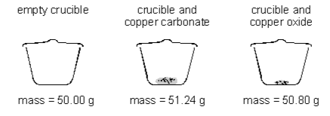
- Two pupils heated some copper carbonate in a crucible. They recorded the mass of the crucible and contents before and after heating.

(a) The word equation for this reaction is:
copper carbonate → copper oxide + carbon dioxide
- What mass of carbon dioxide is given off in this reaction? Give the unit.
- What is the name of this type of chemical reaction?
(b) The pupils then heated some magnesium in another crucible. They worked carefully and did not lose any of the magnesium oxide which formed. They recorded the mass of the crucible and contents before and after heating.
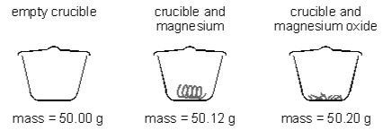
- Write a word equation for the reaction.
- Why does the mass of the contents of the crucible increase in this reaction?
- What is this type of chemical reaction called?

- Complete the table

Type of reaction | Definition
Oxidation
Thermal decomposition
Combustion

- For each reaction, identify the type of reaction (the equations are not balanced).

a) CH₄ + O₂ CO₂ + H₂O

b) Mg + O₂ MgO

c) CaCO₃ CaO + CO₂

- Explain why combustion is also an oxidation reaction
- In the following reaction:
CuCO₃ CuO + CO₂
247g of copper carbonate was heated and 88g of carbon dioxide was given off. Calculate the mass of copper oxide produced.
- the boxes together: 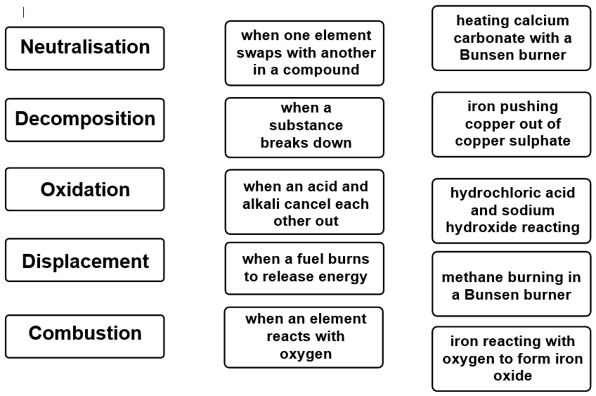
Lesson 5: Neutralisation
Lesson Key Words
atom reactants products balanced equation reactant product neutralisation

RETRIEVAL AND WCSI/WPS
Core ideas- Reading, models, activities
Core Activity: Reading
Remember from year 7, that acids are substances which have a pH of less than 7. Neutral substances have a pH of 7 and then alkaline substances have a pH of more than 7. Universal indicator can be added to a substance and will cause a colour change. The colour change can then be compared to the pH scale and a pH for that substance can then be given. When an acid and an alkali are mixed together, they will form a salt and water.
Acid + alkali → Salt + water
An alkali is a soluble base. They have the surname ‘hydroxide.’ For example:
Hydrochloric acid + sodium hydroxide → sodium chloride + water

Core questions:
- complete the equations below:
- Sodium hydroxide + hydrochloric acid →
- Calcium hydroxide + sulphuric acid →
- Potassium hydroxide + ? → Potassium nitrate + ?
- ? + ? → Magnesium chloride + ?

Core Activity:
Practical – titration to measure how much acid it takes to neutralise a known volume of alkali
Method:
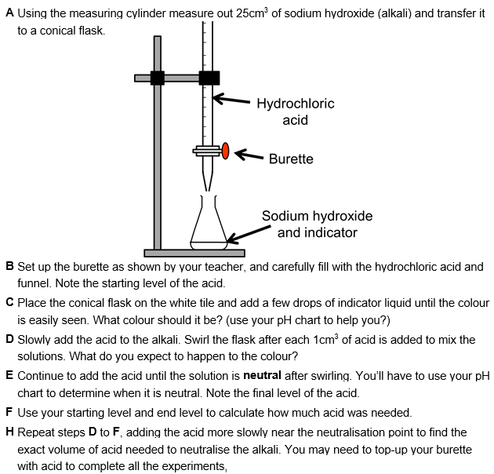
Trial number | 1 | 2 | 3 | 4 | Average
Volume of acid (cm³)

Application questions:

- Potassium hydroxide + hydrochloric acid → ? + ?
- What is the general word equation for when an acid reacts with an alkali?
- What pH range does an acid have?
- What colours would universal indicator go if an acid was tested?
- What pH does a neutral substance have?
- What colour does universal indicator go when a neutral substance is tested?
- Give an example of a neutral substance
- What is the general word equation for when an acid reacts with metal?
- What is the general word equation for when an acid reacts with a metal carbonate?
- What pH range does an alkali have?
- What colour would universal indicator go if an alkaline substance was tested?
- What is the general word equation for when an acid reacts with a metal oxide?
- How do you test for carbon dioxide?
- How do you test for hydrogen?
- What are titrations used for?

Lesson 6: Salt preparation
Lesson Key Words
reactants products balanced equation reactant product neutralisation

RETRIEVAL AND WCSI/WPS
Core ideas- Reading, models, activities
Core Activity: Reading
As we have seen in previous lessons, there are 4 different ways in which salts can be made in the lab. These are shown in the equations below:

Metal + acid → Salt + hydrogen
Metal oxide + acid → salt + water
Metal carbonate + acid → salt + water + carbon dioxide
Alkali + acid → salt + water

Core Activity: Read the two methods for making copper (II) chloride below and find any errors and correct them. Which method is better and why?
Method 1
- Measure out some sulphuric acid into a beaker
- Take some pieces of copper metal and add them to the beaker
- There will be a gas given off – it will be hydrogen
- When the reaction has finished, put the solution into an evaporating dish
- Leave it for a few days and you’ll have crystals of copper chloride

Risk assessment:
Be careful not to spill any acid.
Keep the hydrogen away from any lit flames.
Method 2
- Measure out 25cm³ of hydrochloric acid into a beaker
- Heat it gently while adding spatulas of copper oxide and stirring
- When no more will dissolve, the acid is fully neutralised.
- Filter the solution to remove any excess copper oxide using a filter funnel and paper
- Tip the solution into an evaporating dish and put it into a drying oven for a day or two
- The water will evaporate, leaving crystals of copper chloride

Cu + 2HCl → CuCl₂ + H₂O

Hazard (what is dangerous?) | Risk (what could happen?) | Safety precautions
Hydrochloric acid | Corrosive and irritant | Wear goggles  Wash it off if spilled on skin
Hot equipment | burns | Only heat for 30-60 seconds. Leave it to cool before putting away

Key things to include when writing a method for an experiment:
- Chemicals listed
- Equipment listed
- Volume and masses included
- Clear and detailed description of what to do with the equipment
- Include diagrams where appropriate
- Any hazards identified, and what the risk of these hazards are
- How to minimise risk from these hazards

Core Questions:
- What is the general word equation for when an acid reacts with an alkali?
- What pH range do alkalis have?
- What indicator can we use to test the pH of a substance?
- What is the general word equation for when a metal carbonate reacts with an acid?

Application questions:

- What is a base?
- What common surname do all alkalis have?
- What is the chemical formula for sulphuric acid?
- How many of each type of atom are there in nitric acid?
- Sulphuric acid + magnesium → ? + ?
- Hydrochloric acid + calcium carbonate → ? + ? + ?

Lesson 7: Combustion

Lesson Key Words
reactants products balanced equation reactant product combustion complete incomplete

RETRIEVAL AND WCSI/WPS
Core ideas- Reading, models, activities
Core Activity: Reading
Fire is one of the most important discoveries in human history. Fire has provided warmth through the cold winters of our ancestors. Fire has cooked our food and fired our clay pots. Fire has allowed us to extract metals from the ground to make the machines of the industrial revolution. Fire has allowed us to release energy from fuels like coal, oil and natural gas. This energy was used to power steam and, more recently, the internal combustion engine. It is safe to say that the story of human civilisation is the story of fire.
Fire itself is the product of combustion. Combustion is an oxidation reaction. It happens when organic molecules (made mainly of carbon and hydrogen) are reacted with oxygen. The products of combustion are carbon dioxide and water. There is also a large amount of energy released to the surroundings.
A common type of fuel is an alkane. These saturated hydrocarbons are found in the ground as crude oil. They are made of only carbon and hydrogen and they release huge amounts of energy when they combust. Examples include natural gas (methane) which is used for cooking and heating

Core Activity: Demo practical
Products of combustion

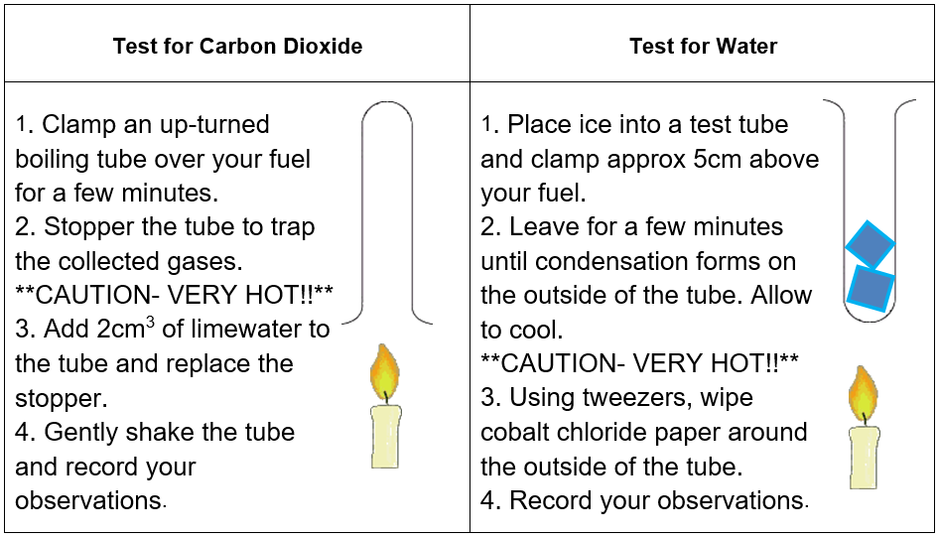

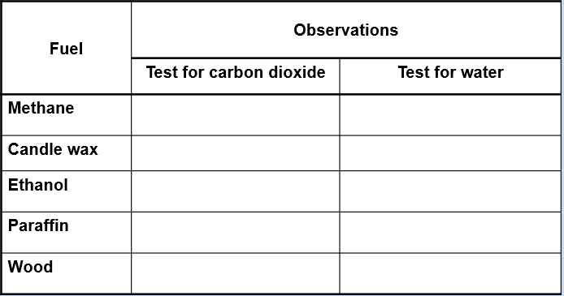
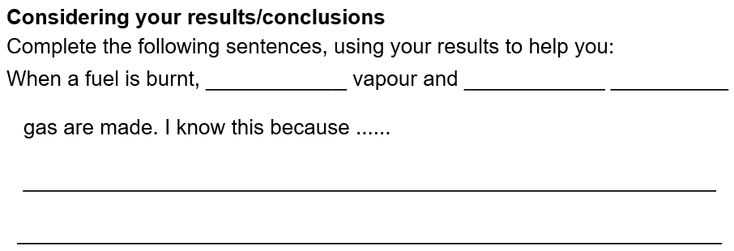

Core Activity: Reading
Complete combustion
Complete combustion is when there is an excess of oxygen present. A roaring blue Bunsen flame is an example of complete combustion. As there is more than enough oxygen every single atom of carbon and hydrogen can bond with oxygen. Complete combustion forms carbon dioxide and water. Because so many new bonds are made it releases the most amount of heat. Carbon dioxide is a greenhouse gas and rising levels have been thought to be the main cause of climate change through global warming.

Incomplete combustion
In complete combustion is when there is a limited amount of oxygen. A yellow Bunsen flame is from incomplete combustion. There is not enough oxygen to form carbon dioxide (CO₂) so instead carbon monoxide (CO) or soot (C) form. The soot causes smoke and soot which can give people trouble with breathing. It has also caused smog and blackened buildings. The carbon monoxide is an odourless and colourless gas. It is toxic because it sticks to red blood cells in the place of oxygen, suffocating the person. By law all rented properties are required to have a carbon monoxide detector by their gas boiler to prevent carbon monoxide poisoning. Incomplete combustion releases less heat as fewer bonds are formed.
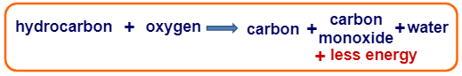
Core question:
- Complete the table below to summarise the differences in the types of combustion

​ | Complete combustion​ | Incomplete combustion​
Oxygen supply​ | ​  ​ | ​
Colour of flame​ | ​  ​ | ​
Energy released​ | ​  ​ | ​
Smoke/soot produced​ | ​  ​ | ​
Environmental issue​ | ​  ​ | ​

Application questions:
- Use the Venn diagram below to compare complete and incomplete combustion

Complete combustion

Incomplete combustion

- (Extended response) Compare complete and incomplete combustion
Hint: Compare means mention how they are the same and different
Useful vocab: Contrastingly, however, similarities
Keywords: oxidation, energy, flame, products, oxygen​, smoke, soot, greenhouse, toxic

- This apparatus can collect the products of a combustion reaction. Label the diagram using words from the box.
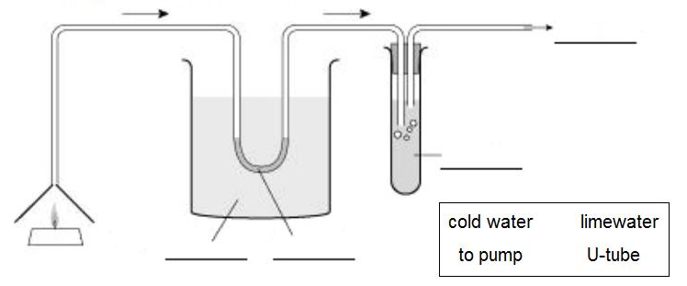

- Which two gases rise from the candle and enter the delivery tube?
- What collects in the U-tube?
- Why is the U-tube cooled?
- Blue cobalt chloride paper is placed in the U-tube. What is seen and what does it prove?
- What happens to the limewater? What does this prove?
- Candle wax contains the hydrocarbon pentacosane. What is meant by the term hydrocarbon?
- Write the word equation for the combustion of pentacosane:

Balancing complete combustion equations is easier than it seems if you follow these simple rules:

- If the fuel has an odd number of carbons (e.g., CH₄, C₃H₈) you need one molecule of fuel in the equation.
- If the fuel has an even number of carbons (e.g., C₂H₆) you need two molecules of fuel in the equation.
- Each carbon in the reactants makes one molecule of CO₂ in the products.
- Every two hydrogens in the reactants make one molecule of H₂O in the products.
- Then all you need to do is count up the oxygen atoms in the products and balance this in the reactants.

- Note: this only works for complete combustion of alkanes.

- Try writing balanced equations for combustion of:

- Propane (C₃H₈)
- Ethane (C₂H₆)
- Pentane (C₅H₁₂)
- Decane (C₁₀H₂₂)
- Pentacosane – candle wax (C₂₅H₅₂)

Check your understanding:
- When carbon burns it combines with oxygen to form carbon dioxide. The diagram shows some carbon atoms reacting with some oxygen molecules.
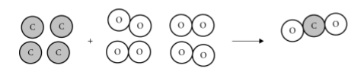
- Finish the diagram by drawing the correct number of carbon dioxide molecules. One has been done for you.
- Write ‘reactants’ and ‘products’ under the correct sides of the diagram.
- 12 g of carbon reacted with 32 g of oxygen. What mass of carbon dioxide was formed? Circle the correct answer.
12 g 24 g 32 g 44 g 64 g
- This diagram below shows the reaction between marble chips and acid.
This is the word equation for the reaction:
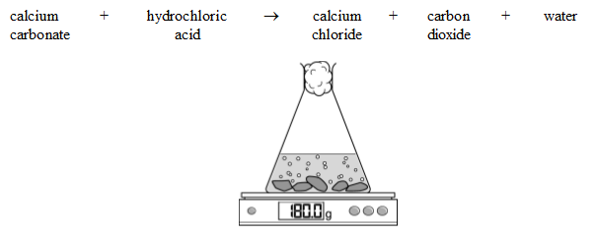
- Is carbon dioxide a solid, a liquid or a gas?
- What would you expect the balance to read when the reaction has finished? Circle the correct answer. 179 g 180 g 181 g
- Explain your answer to part b.
- If you heat a piece of copper, it combines with oxygen from the air to form a black layer of copper oxide.
- Write a word equation for this reaction.
- How would the mass of your piece of copper change as you heated it?
- Why would this happen?

