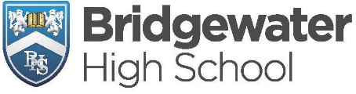
YEAR 8 JANUARY 2023 ASSESSMENTS

Date | Lesson 1  09:10 | Lesson 2  10:10 | Lesson 3  11:30 | Lesson 4  13:10 | Lesson 5  14:10
Tuesday 24th January | Stockton  MATHS | Appleton  SCIENCE |  | Stockton  ENGLISH
Wednesday 25th January | Appleton  MATHS | Stockton  SCIENCE |  |  | Appleton  ENGLISH

- Assessments will take place in the GYM for the majority of students. For those with an Access Arrangement, assessments will take place in the LIBRARY
- For all other subjects, assessments will take place in normal classrooms and at the normal scheduled lesson times. Please consult your child’s timetable to see when these assessments are taking place.

