Food Labelling
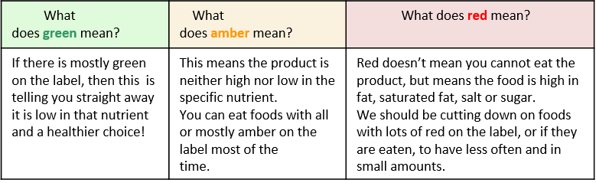

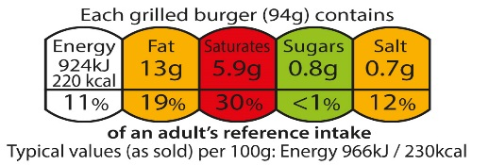

Consider personal hygiene issues when working in the kitchen.- Check your book.
- What should you wear?
Health & Safety in the Food Room:
Personal Hygiene
Wash hands in soapy water.
Tie long hair back.
Wear and apron and tuck tie in.
Roll back sleeves.
- How should you prepare yourself before you start to ready ingredients and cook?
- How should you clean up after cooking?
What about safety issues? Check your book
- How can you ensure you are safe when working in the kitchen?
- How can you protect yourself?
NUTRIENTS
- How the body uses nutrients:
- Protein–growth and repair –found in meats/fish/eggs/pulses
- Carbohydrates= slow or fast release energy –found in bread/pasta/rice/potatoes
- Vitamins and minerals –boost immune system –found in fruit/vegetables e.g. Calcium–strong bones and teeth –milk/cheese/yoghurt
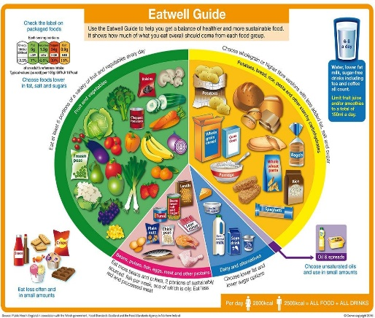
- Fats–protects vital organs, keeps you warm –found in oil, butter, dairy products, sweets and chocolates.

The Eatwell Guide

8 Tips to Healthy Eating
1. Base your meals on higher fibre starchy carbohydrates
Starchy carbohydrates should make up just over a third of the food you eat. They include potatoes, bread, rice, pasta and cereals.
2. Eat lots of fruit and veg
It's recommended that you eat at least 5 portions of a variety of fruit and veg every day. They can be fresh, frozen, canned, dried or juiced.
3. Eat more fish, including a portion of oily fish
Fish is a good source of protein and contains many vitamins and minerals.
Aim to eat at least 2 portions of fish a week, including at least 1 portion of oily fish.
4. Cut down on saturated fat and sugar
Saturated fat
You need some fat in your diet, but it's important to pay attention to the amount and type of fat you're eating.
5. Eat less salt: no more than 6g a day for adults
Eating too much salt can raise your blood pressure. People with high blood pressure are more likely to develop heart disease or have a stroke.
6. Get active and be a healthy weight
As well as eating healthily, regular exercise may help reduce your risk of getting serious health conditions. It's also important for your overall health and wellbeing.
7. Do not get thirsty
The government recommends drinking 6 to 8 glasses every day. This is in addition to the fluid you get from the food you eat.
8. Do not skip breakfast
Some people skip breakfast because they think it'll help them lose weight.
But a healthy breakfast high in fibre and low in fat, sugar and salt can form part of a balanced diet, and can help you get the nutrients you need for good health.

Dairy foods
Milk – Comes from cows, sheep, goats. Can be skimmed, semi skimmed or full cream.  Cheese – Mature to mild. Cheese is made from milk. It is judged on its strength from 1-5. | Yogurt – Made from milk using a culture to thicken it. It can come in many forms and flavours.  Cream – is used to make butter. It is the fat on milk which is skimmed off.

Pasteurisation—Milk is heated after milking to kill the food poisoning bacteria .
Homogenisation—Milk is spun in a centrifuge to stop the fat separating during the bottling process
Pre – Reading = Food Labelling and Advertising

Lidl to ditch cartoons on cereals

Article Published - 3 January 2020
Lidl has said it will remove cartoon characters from its own-brand cereals to help parents buy healthy products. It hopes that the rebranded packaging, to be introduced in the spring, will ease the pressure of children's "pester power". Health experts welcomed the move but called for government regulations on "junk food marketing". A group of MPs has previously recommended a ban on cartoons on unhealthy foods.

Lidl said it will rebrand eight of its own-brand Crownfield products in total, including Choco Shells, which features two cartoon penguins on the box, and Rice Snaps, which is advertised with a grinning cartoon crocodile. The new packaging will be free from cartoons.
Georgina Hall, Lidl’s head of marketing said it wants to help parents "make healthy and informed choices" about the food they buy for their children. "We know pester power can cause difficult battles on the shop floor and we're hoping that removing cartoon characters from cereal packaging will ease some of the pressure parents are under," she said. She stressed that the company seeks to make "good food accessible for everyone" and "help customers lead healthier lives."

According to Lidl's website, a serving of its Honey and Peanuts Corn Flakes - which features a cartoon bee on the box - contains 14g of sugar, compared to 0.4g in its regular Corn Flakes. Caroline Cerny, of the Obesity Health Alliance - a coalition of organisations such as the Royal College of Paediatrics and Child Health and the British Medical Association - welcomed what it called a "responsible approach".
"We know that the use of cartoon characters on sugary products is a marketing technique used by the food industry to put their unhealthy products firmly centre stage in children's minds," she said. However, she noted that more needs to be done than one retailer changing a category of products. "We need the government to introduce regulations to create a level playing field and protect children from all types of junk food marketing," she added.
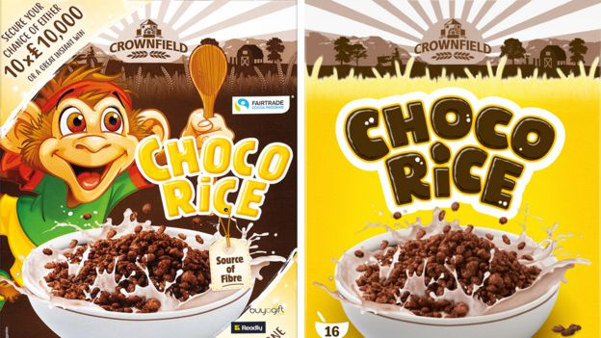
The move comes more than a year and a half after the health select committee recommended a ban on cartoons on sugary foods, such as Tony the Tiger and the Milky Bar Kid. In October, England's outgoing chief medical officer, Dame Sally Davies, called for extra taxes placed on unhealthy foods to tackle child obesity. In her final report, she also called for tighter rules on advertising.
Old Packaging Vs New Packaging
Old Packaging Vs New Packaging

