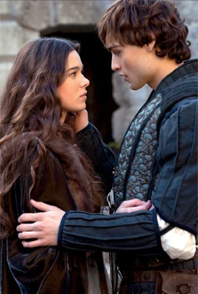
Romeo and Juliet
Remember:
- Until the death of Mercutio in Act 3, the play has aspects of comedy. Act 3 is the turning point that sends the play into tragedy.
- The entire action of the play takes place in less than four days.
- Courtly love – Romeo’s idealistic and unrequited love for Rosaline.
- Passionate love – the love of Romeo and Juliet which overcomes boundaries,
restrictions and family feuds.
- Physical love/Lust – Romeo and Juliet’s consummation of their marriage: the bawdy jokes at the opening of the play; The Nurse’s comments about sex.
- Family love – distant relationship between Juliet and her mother compared with her close bond with the Nurse. Similar relationship with Romeo and Friar Lawrence.

Main themes

1.5 If he be married, My grave is like to be my wedding bed. / My only love sprung from my only hate!
2.2 It is too rash, too unadvised, too sudden , too like… lightning
2.2 My bounty is as boundless as the sea, my love as deep / Swear not by the moon, the inconstant moon
3.2 O serpent heart, hid with a flowering face! 3.5 Proud can I never be of what I hate!
4.2 [to Capulet] Henceforward I am ever ruled by you 5.3 O happy dagger.
1.1 O brawling love, O loving hate / Love is a smoke made with the fume of sighs
1.4 Some consequence yet hanging in the stars, … some vile forfeit of untimely death
1.5 Did my heart love til now? I never saw true beauty till this night.
3.1 I do protest I never injured thee, but loved thee better than thou canst devise.
3.1 O I am fortune’s fool. 3.1 A plague a’both your houses!
1.1 I do but keep the peace. Put up thy sword or manage it to part these men with me.
1.3 Compare her face with some that I shall show, And I will make thee think thy swan a crow.
3.1 Withdraw to some private place… or reason coldly of your grievances
1.1 Peace? I hate the word, As I hate hell, all Montagues, and thee.
1.5 Now by the stock and honour of my kin to strike him dead I hold it not a sin.
1.2 My child is yet a stranger in the world / Within her scope of choice lies my consent
1.2 And too soon marred are those too early made
3.4 I think she will be ruled in all respects by me
3.5 Hang thee, young baggage, disobedient wretch! / Hang, beg, starve, die in the streets
1.3 I was your mother much upon these years 3.5 I would the fool were married to her grave.
3.5 I think it best you married with the County. Oh, he's a lovely gentleman. Romeo's a dishclout to him.
2.3 Young men’s love then lies not truly in their hearts but in their eyes.
2.3 This alliance may so happy prove to turn your household’s rancour to pure love.
2.3 Wisely and slow, they stumble that run fast. 2.6 These violent delights have violent ends.
1.4 You are a lover, borrow Cupid’s wings 1.4 If love be rough with you, be rough with love.
3.1 Ask for me tomorrow and you shall find me a grave man

