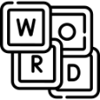

**Y7 - Quizzes**

**Y7 - KIM Vocabulary**

**Y7 - Read, Cover, Say, Write, Check**

* Write a quiz on what you have learned about a topic.
* Ask friends and family to test you.
* Your teacher may use your quiz as a starter activity.

**K**eyword > **I**nformation to show meaning > draw a picture as a **M**emory Clue

|  |  |  |
| --- | --- | --- |
| **K** | **I** | **M** |
| simile | comparison using “like” or “as” |  |

* Use the key words in a sentence
* Read the information from a specific part of your Knowledge Organiser or text.
* Cover it over, say the information aloud. (You could recite it to someone at home).
* Write the information down from memory.
* Check your answer.
* Repeat until you can write the information perfectly.



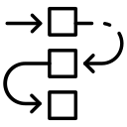

**Y8 – Dual Coding**

**Y8 - Flowcharts**

**Y8 - Clocks**

* Draw a diagram to sequence steps in a process, key events in a story, or over a time period.
* Use pictures to help remember information.
* Having images and words gives two ways to remember details.

= prophecies, witches, ambition (Macbeth)

* Use the template or divide a page into 12 sections (like a clock face)
* Add key information about the topic you are studying in each section.



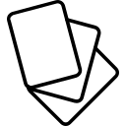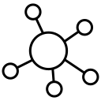

**Y9 – Cornell Notes**

**Y9 – Flashcards**

**Y9 – Mind Maps**

* Create a set of flashcards containing key pieces of information and vocabulary for a topic.
* On one side, write a quotation or a question about your topic.
* On the other side write key details.
* Test yourself.
* 3 boxes
* A mind map is used to represent information, ideas and concepts.
* Use colourful words linked by lines to show how they link to the concept or theme.
* This note-taking method can be used instead of flashcards.

|  |  |
| --- | --- |
| **TITLE** | |
| **Key points** | **Main Notes** |
| Reduce to key points & questions | Note details as fully as possible |
| **Summary** | |
|  | |

