Y8 EOY Revision
The Elements of Music
DRSMITH is the acronym that we use to remember the musical elements
- Dynamics – The volume of the music.
- Rhythm – A pattern of sounds and silences.
- Structure – The layout of the music.
- Melody – The tune of the music.
- Instrumentation – The instruments used in the music.
- Texture – The layers in the music.
- Tempo – The speed of the music.
- Harmony – When two or more notes are played at the same time.
Dynamics
Key Word | Definition | Symbol
Piano | Quiet | p
Mezzo Piano | Medium Quiet | mp
Mezzo Forte | Medium Loud | mf
Forte | Loud | f
Crescendo | Getting Louder
Diminuendo | Getting Quieter

Rhythm
Name | Symbol | Duration (No. of Beats)
Semi-breve |  | 4
Minim |  | 2
Crotchet |  | 1
Quaver |  | ½
Semi-quaver |  | ¼

Key Words
- Polyrhythm – two different rhythms being performed at the same time.
- Dotted note – ½ the notes original value is added on again. For example. A dotted crotchet is worth 1.5 beats. (crotchet is worth 1, ½ of 1 is a ½. Add together 1 and ½ to get 1.5)
- Tied note - Two tied notes means you add the note values together to make one long note.
Structure
Key Words
- Verse
- Chorus
- Bridge
- Intro
- Outro
Melody
The melody of the song is commonly the vocal line (what the singer is doing).
The melody of a song is created by putting together notes of different pitches.
Pitch – How high or low a note is.
Music Notation is written using 7 letters of the alphabet - ABCDEFG

In music we write our notes on different clefs
- Treble Clef
- To remember the notes on the lines we use the phrase
EVERY GREEN BUS DRIVES FAST
- To remember the notes in the spaces we use the word
FACE
- Bass Clef
- To remember the notes on the lines we use the phrase
GREEN BUSES DRIVE FAST ALWAYS
- To remember the notes in the spaces we use the phrase
ALL COWS EAT GRASS
Leger Lines – lines that are added to the stave to allow for more notes.
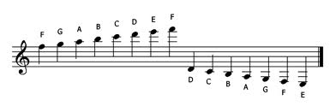

Instrumentation
There are 4 Orchestral Families
- Strings
- Woodwind
- Brass
- Percussion
The smaller the instrument the higher it is in pitch.
A bass guitar will often play a bassline. A bassline is a short melody that is low in pitch.
Texture
Monophonic – a single layer of music.
Unison – everyone performing the same thing.
Melody and accompaniment – one main tune with other instruments supporting it.
Polyphonic – Multiple independent melodies happening at the same time.
Tempo
Key Word | Definition
Largo | Slow
Moderato | Medium
Allegro | Fast
Presto | Very Fast

Harmony
When two or more people sing different notes at the same time then this is a vocal harmony.
Chords – more than one note played at the same time.

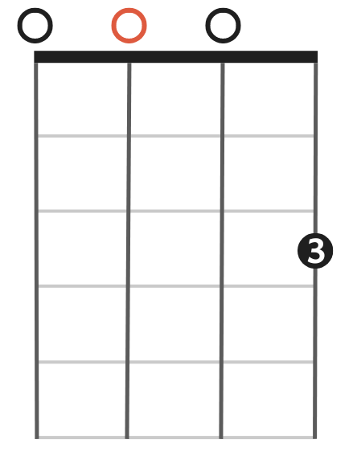
Ukulele chords
- The circle with the number in it is where your finger goes.
- The number in the circle is which finger you use.
- The horizontal lines represent the frets.
- The vertical lines represent the strings.

HipHop and Rap
4 Main Elements of HipHop
- Rap
- Djing
- Breakdancing
- Graffiti
Different Types of Rhymes
- Perfect rhyme - Both the ending consonants (if any) and stressed vowel sounds of the two words match exactly.
- Imperfect rhyme - The two words are similar to one another but are not perfect rhymes. Often the consonant sound at the end of the word is different.
- Multisyllabic rhyme - Both the ending consonants (if any) and stressed vowel sounds of the two words match exactly.
Vocal Projection – Talking/performing in a louder voice to be heard.
Piano
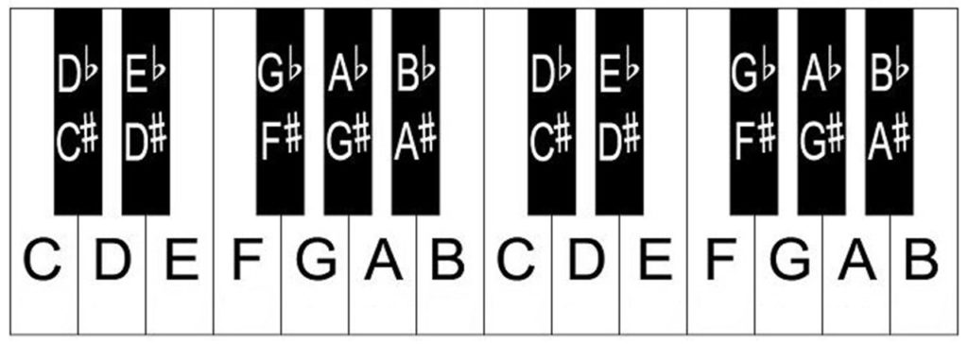
C is to the left of the two black keys.

The sharp note is to the right and the flat note is to the left.

