TRANSITION ACTIVITY BOOKLET
YEAR 7 – 2024
HEAD OF YEAR = Miss Betts
ASSISTANT HEAD OF YEAR = Mr Smith

Name

Previous School

Introduction
Moving from primary to secondary school is an exciting, but sometimes scary time! A new building, new rules, new teachers, new routines and new friends are just some of the changes you will experience but this booklet will help you get used to some of the routines and features of your new school!
All about me
Preferred Name
Age
Family Members
Pets
Hobbies
Places I enjoy
being most
Friends coming to Bridgewater
Favourite Subject(s)
Favourite Book
Dream Job
Best Place Visited

More about me

- What am I good at?
________________________________________________________________________________________________________________________________________________________________________________________________
- What would my family/friends say I am good at?
________________________________________________________________________________________________________________________________________________________________________________________________
- What am I most proud of?
________________________________________________________________________________________________________________________________________________________________________________________________
- What do I need to do to improve or make better progress?
________________________________________________________________________________________________________________________________________________________________________________________________
- What leadership opportunities have I had?
________________________________________________________________________________________________________________________________________________________________________________________________
- What would I like to achieve at Bridgewater?
________________________________________________________________________________________________________________________________________________________________________________________________
- What are my aims for Year 7?
________________________________________________________________________________________________________________________________________________________________________________________________
My learning journey

Life is a journey! Think back through primary school and write down your favourite memories or events that have shaped you to become the amazing person you are!

Finding out about Bridgewater High

Here are a few questions to help you to get used to looking on our website or our brand new Welcome Booklet. See if you can find the answers to as many as you can!
www.bridgewaterhigh.org
What is the school address (Lower Site) and the phone number?
What is the name of the Principal?
What time does school start?
What time does school end?
What is the name of the website/app we use for homework?
Name two Key Stage 3 subjects you will study beginning with F.
To be in the green group of attendance (“No Concern”), what does your % attendance need to be?
Name three activities you can take part in as part of our enrichment programme.

Getting to school safely and on time
Getting to Bridgewater safely is just as important as being there. In the box below, draw the route you are going to take to school (whether that’s walking, cycling, driving or by bus). Identify spots where there could be hazards (e.g. busy roads) and explain how you will manage this safely!

Subjects I will study at Bridgewater

Find the subjects below in the word search – they are vertical, horizontal, backwards and diagonal!

S | E | R | H | N | K | D | R | Y | I | O | P | E | S | X | Z | N | D
O | L | E | N | G | L | I | S | H | T | Y | E | N | X | B | T | V | E
Q | V | B | E | R | I | L | F | V | W | X | R | J | I | R | K | L | S
T | G | N | X | R | W | U | I | H | D | F | S | O | A | P | J | W | I
R | D | A | N | C | E | T | O | E | Z | C | O | F | N | R | U | N | G
H | U | K | O | Y | Y | Y | L | H | W | E | N | E | B | Q | J | R | N
J | Y | W | M | P | E | U | F | U | M | M | A | T | H | S | T | R | T
B | E | F | Z | J | Q | H | G | O | Y | H | L | H | R | U | A | N | E
H | O | N | W | C | W | A | R | H | O | T | D | X | Q | A | R | J | C
C | L | U | H | E | D | M | P | P | I | U | E | B | M | I | Q | I | H
N | N | O | I | W | B | A | Q | W | N | V | V | R | N | K | D | S | N
E | X | P | S | R | R | R | X | O | X | S | E | W | Q | F | P | Z | O
R | D | I | T | G | M | D | I | F | A | G | L | J | P | E | S | O | L
F | I | P | O | I | V | G | Y | X | S | U | O | I | O | Y | H | L | O
S | H | E | R | O | I | X | O | S | T | M | P | E | H | X | E | W | G
L | G | W | Y | L | C | W | I | C | T | T | M | W | C | N | F | Y | Y
X | E | G | E | W | S | S | J | E | C | N | E | I | C | S | V | H | Z
Q | X | R | D | Q | L | A | Z | Q | G | O | N | N | Z | P | P | I | E
A | M | U | S | I | C | T | F | O | O | D | T | E | C | H | S | D | G

English | Art
Maths | Drama
Science | Music
History | Dance
Geography | PE
Religion | Food Tech
French | Design Technology
German | ICT
Personal Development | PSHE

Questions
Look at the timetable in your Welcome Booklet…

- What lesson do you have Period 5 on a Thursday (don’t forget that the first column is Tutorial with your form tutor)? ..................................
- What are the initials of the teacher who teaches you period 3 on a Friday?
................................
- What are the initials of the teacher who teaches you period 2 on a Monday?
................................
- What are the initials of your Music teacher? ..................................
- How long is tutor time on each day? ..................................
- How long is lunch and break combined? ..................................
- Which room is Dance in? ..................................
- How many times in this week do you have the following:
  - Maths: ..................................
  - English: ..................................
  - History: ..................................
- Which days do you need your PE kit (you will need it for Dance as well)?
………………………………………………………………………………
- Who are your two Maths teachers (their initials)? ………………………………
- Which would be your favourite day? ..................................

Getting around the school building
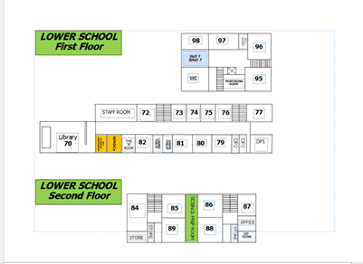
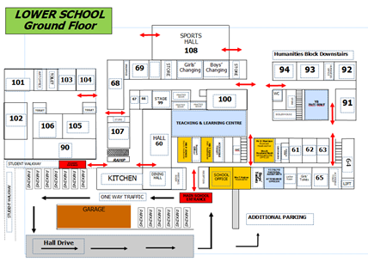
Some images of the school building
Main office area
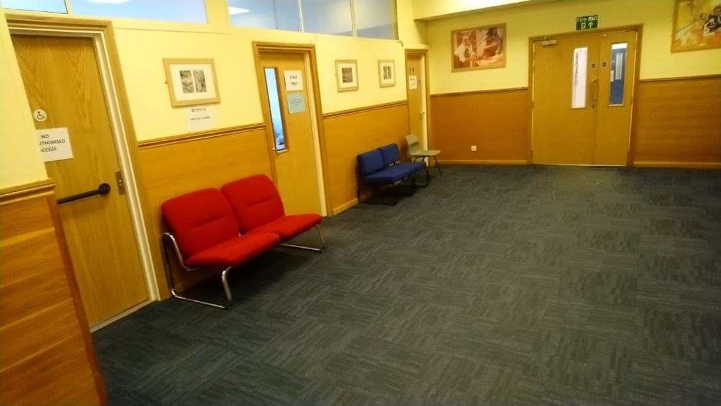

In this area, you will find our main school office as well as the offices of Mrs Hatton (Headteacher), Mr Jones (Deputy Headteacher), Mr Eden (Assistant Headteacher) and Mrs Hindle (Support Officer).

The canteen and hall
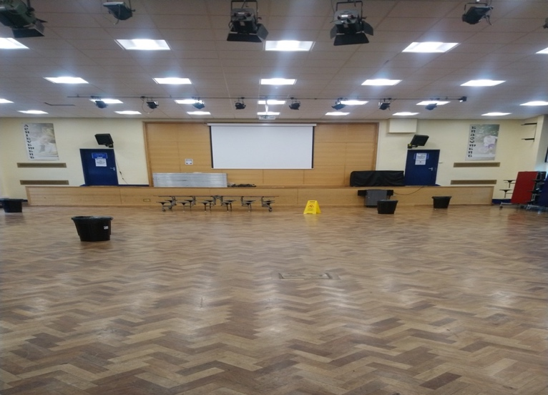
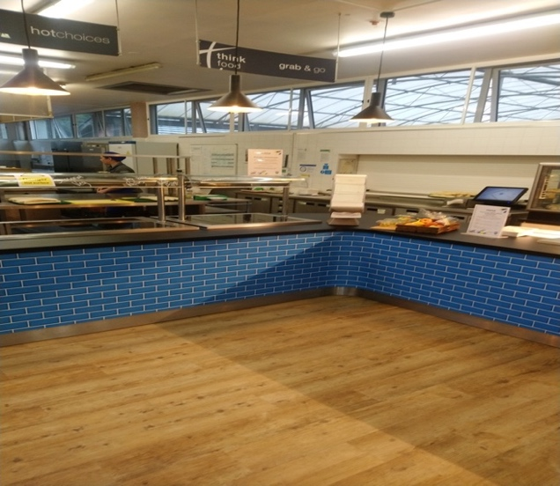

This is where you would go to eat at break and lunchtimes. We have lots of food options available for you. You would then eat it in our main hall which is where you also have assemblies.
The Learning Resource Centre
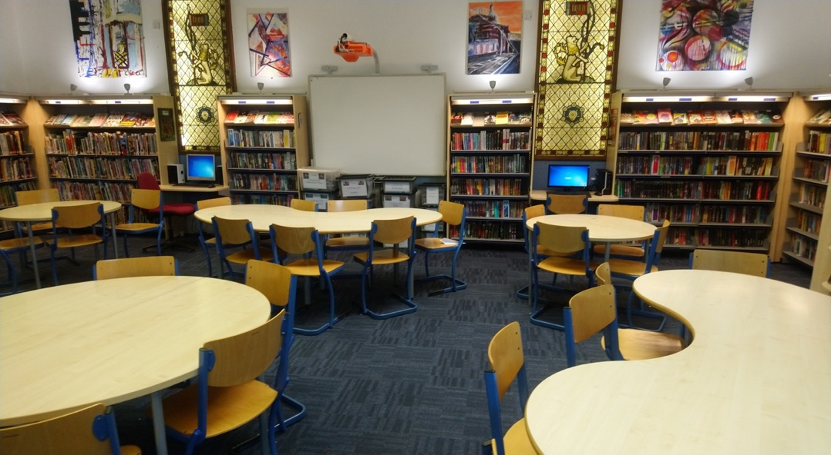

This is our Learning Resource Centre (Library) which is well stocked with lots of great books to read.

The school yard
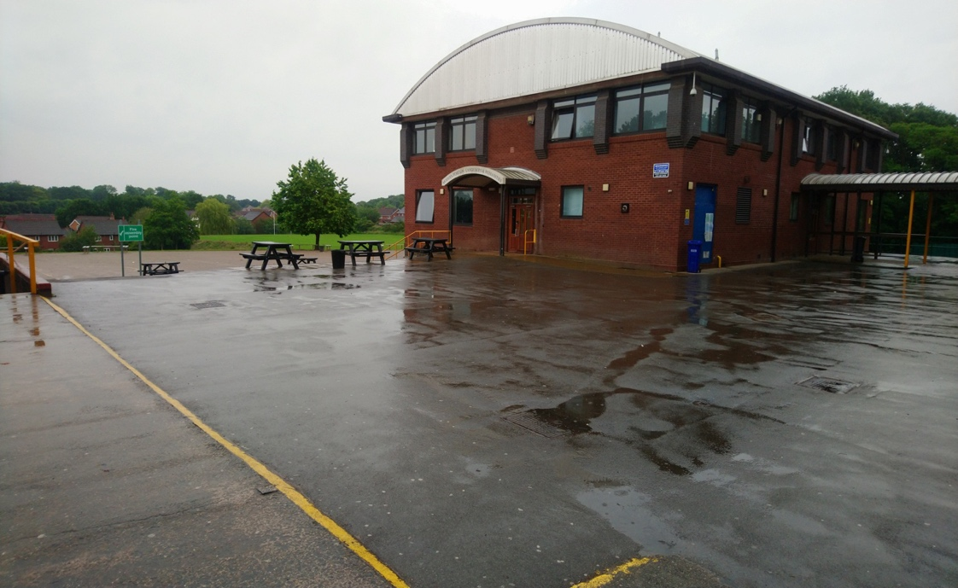

This is the view leading out of the main school building and across the school playground to the Humanities building.

What equipment will I need?
At secondary school, you will be moving around to different classrooms for different lessons. You could be in six classrooms in one day. This means that you need to bring all the equipment you will require with you for the day. You can keep larger items such as your PE kit in your locker, however you can only go to your locker before school, at break and lunchtime and at the end of the day. Below are some items you will need to bring – can you identify them and add anything else?

Our values at Bridgewater

Use your Welcome Booklet to remind yourself of our six school values and fill in the remaining three below:

1. Kindness 4.

2. Pride 5.

3. Collaboration 6.

Looking at the first three of these, KINDNESS, PRIDE and COLLABORATION, which of the following statements would you match to those three values (some may count as two different values)?

Having your shirt tucked in neatly
High level of respect shown to all
Working successfully as part of a team

Holding the door open for a teacher
Saying good morning to people as you pass
Supporting others

Consistent punctuality over the whole year
Sitting with someone who is alone at lunch
Going above and beyond with your work

Being respectful to other staff and students

Having a leadership role in a group
Giving someone a compliment
Your school email account

Every Bridgewater pupil has their own email account.
Your email address will be the number 23 followed by your surname, followed by your first name, followed by @bridgewaterhigh.com. An example would be: 23smitha@bridgewaterhigh.com
To access your emails simply go to www.office.com and log in with this email address and your school network password which will be given to you in September (the password you will use to log in to a computer in school), then go to Outlook. It is here that you can also access Teams and OneDrive which some teachers also use from time to time.
Also, when you go to www.office.com, there will be a box on the right-hand side allowing you to Install Office (see image below). This means that you can download the Office 365 apps on up to five computers for free!
You can also use the Outlook app on a phone to access your emails.
Don’t worry if this seems a lot to take in! You will be guided through these processes and will be given lots of reminders. Also don’t be afraid to ask for help!

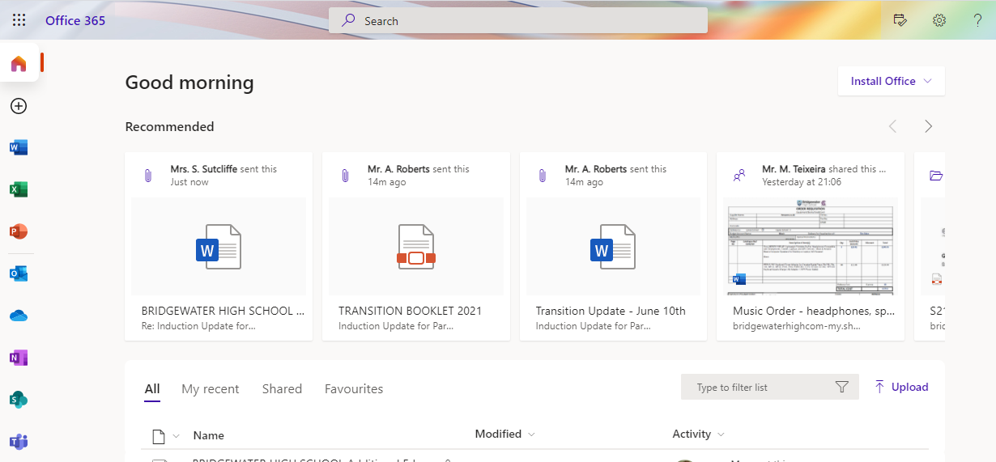

Future leaders

The Year 7 Student Leadership Programme
What is a student Leader?
- A student leader is anyone who takes on a voluntary role at Bridgewater.
- As a student leader, you are in a position of responsibility to have a positive impact in the student community, running events and activities, making changes to the school, or providing support to your fellow students.
- Not only do student leaders do great things for their peers, but also develop valuable skills they can use in their future and access additional opportunities to help them develop further.

What does student leadership look like in Year 7?
In Year 7, we will teach you what kinds of skills you will need to be a good leader in the future
- These skills have been split into competencies which you will complete over a number of months:
- Being a positive role model
- Developing myself
- Contributing to my community
- Working with others
You have an opportunity to complete a Bronze, Silver and Gold Award, with a chance at a Platinum Award too (and a special award on Awards Evening) for those who complete the entire programme.
Start thinking already what skills and experience you have which would match the four points above.

Moving to your new school and addressing any worries

These could be useful to think about when you think about starting your new school.
Using two different coloured pens, highlight or colour in the phrases that you are looking forward to in one colour; use a different colour for those you are worried about.

Making new friends | Learning a new timetable
Lunch time | Forgetting equipment
Having a different uniform | Being on time
Finding your way around | Break times
Getting to school | Learning new subjects
Meeting others my own age | Joining new clubs
Being with friends | School rules
Homework | Meeting my form tutor
Meeting my new teachers | Being able to do the work
Being with older pupils | Getting changed for practical activities

Write down anything else that comes to mind.
________________________________________________________________________________________________________________________________________________________________________________________________________________________________________________________________________________________________________________________________

What are you most excited about?
________________________________________________________________
What are you most worried about?
________________________________________________________________

A guide to making new friends
Below is a list of ideas that may help you in making new friends at Bridgewater
- Smile – It’s free and infectious
- Ask questions – Get to know about others
- Join new clubs and activities
- Try something new
- Recognise that we are all different but special in our own way
- Listen and show interest in others
- Treat others as you wish to be treated
- Don’t gossip or make fun of others
- Find out the interests of others – you may share the same ones
- Show these values online too

What are your goals/aims for Bridgewater?
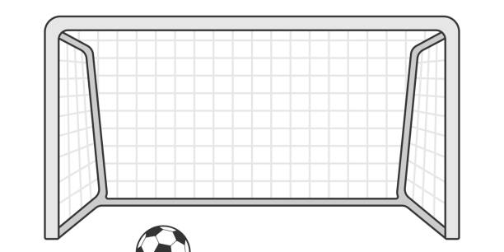
When you go to Bridgewater, you will learn a huge number of new skills, and improve skills you have practised in primary school. In the goal below, try to write in 10 new skills or things you’d like to build on in your years at secondary school.
Beyond Secondary School
After secondary school, you can move onto college or an apprenticeship and then to university or into a job! It’s normal not to know what you want to do yet, but this is a chance for you to have a think about your dream jobs!
You will have careers sessions as part of your Personal Development programme but here is your opportunity to tell us about your dream job:

Dream Job 1: | Dream Job 2:
Key skills needed: | Key skills needed:
Subjects to study: | Subjects to study:

Any questions?
Make a list of up to 5 questions that you still have about coming to Bridgewater. By the end of the first week, you should have an answer!

Writing to your form tutor

Write a letter to your form tutor (we know you have not met them yet!) to tell them a little about yourself and your feelings towards starting Bridgewater:

Dear Tutor

I will be joining Bridgewater High School very soon and I am feeling_______________because_____________________________________________________________________________________________________________________________________________________________________

I am looking forward to
________________________________________________________________________________________________________________________________________________________________________________________________

However, I am a little nervous as
________________________________________________________________________________________________________________________________________________________________________________________________

One thing I would like you to know about me is
________________________________________________________________________________________________________________________________________________________________________________________________

Looking forward to meeting you!
From _____________________________________

FINALLY

THIS IS IMPORTANT…!

You need to be ready to show us what you can achieve!
You must all bring along a piece of written work when you visit us for your induction days. This can be any written work you have completed at primary school but should be a piece of English work you feel most proud of.
We will be collecting these in on your induction days so if you can, bring a photocopy.
This is so that part of the start of your journey with us can be a celebration of the work you are capable of already!

