The Importance of Personal Development
Personal development helps young people understand themselves, manage challenges, and build the emotional skills they need for school, relationships, and adult life. During the teenage years, students experience rapid changes in their brains, bodies, and social worlds. Learning how to recognise emotions, cope with stress and develop healthy habits supports mental wellbeing, builds resilience, and helps students feel more confident and in control. When parents and carers talk openly about these topics at home, it reinforces learning and shows young people that their wellbeing really matters
Curriculum Topic Overview – Year 7 Spring Half Term 1
Combat Worry, Stress & Anxiety
Students explore what stress and anxiety are, how they affect the body and mind, and practical ways to reduce their impact. The focus is on recognising early signs and using healthy coping strategies.
Dealing With Worry
This topic helps students understand the difference between helpful and unhelpful worry. They learn techniques such as problem-solving, letting go of things outside their control, and not allowing worries to take over their thoughts.
The Stress Scale
Students learn to rate their stress levels and recognise when stress is manageable versus overwhelming. This encourages self-awareness and helps them know when to take action or ask for support.
Controlling Our Emotions
This area focuses on emotional regulation — understanding triggers, pausing before reacting, and responding in a calm and constructive way, even in challenging situations.
Five-Minute Meditation
Students are introduced to short mindfulness and breathing exercises that can be used anywhere. These tools help calm the nervous system, improve focus and reduce feelings of overwhelm.
Rewiring Your Brain
This topic explains how the brain can change through habits and repeated behaviours. Students learn how positive thinking patterns, self-talk and practice can strengthen resilience and emotional wellbeing over time.

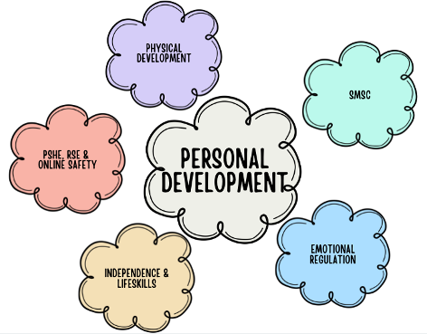
Reflection Questions you can discuss at home

- What situations tend to cause you the most stress or worry at the moment, and how does your body let you know?

- Which strategies from school have you found most helpful when you feel anxious or overwhelmed?

- How do you usually react when strong emotions come up, and what might help you pause before responding next time?

- Have you noticed times when your stress level moves up or down during the day? What seems to influence that?

- What is one small habit or mindset you could practise regularly to support your wellbeing and ‘rewire’ your brain in a positive way?

Encouraging regular, relaxed conversations around these questions can help your child feel supported, understood and more confident in managing their wellbeing.

