The Importance of Personal Development
Personal development helps young people understand themselves, manage challenges, and build the emotional skills they need for school, relationships, and adult life. During the teenage years, students experience rapid changes in their brains, bodies, and social worlds. Learning how to recognise emotions, cope with stress and develop healthy habits supports mental wellbeing, builds resilience, and helps students feel more confident and in control. When parents and carers talk openly about these topics at home, it reinforces learning and shows young people that their wellbeing really matters
Curriculum Topic Overview – Year 7 Spring Half Term 2
Managing Privacy Online
Students explore how to protect their personal information online, understand the risks of oversharing, and make safe choices when using apps, social media, and websites.
The Dangers of Your Internet Algorithm
This topic helps students understand how algorithms shape the content they see online, including risks of bias, manipulation, and misinformation, and strategies to maintain a balanced digital diet.
Social Media Addiction
Students learn to recognise signs of compulsive social media use, the impact it can have on mental health, and techniques to balance screen time with offline activities.
Alcohol and Your Health
This area focuses on understanding the short- and long-term effects of alcohol, making informed choices, and recognising peer pressure around drinking.
Smoking and Nicotine Addiction
Students explore the dangers of smoking and vaping, the addictive properties of nicotine, and strategies for resisting peer pressure and staying smoke-free.
Vaping: A Global Dilemma
This topic examines the rise of vaping, its health consequences, and how marketing and peer influence affect young people’s decisions.

Reflection Questions you can discuss at home
When using apps, social media, or websites, what situations make you feel unsafe or unsure, and how do you usually protect your personal information?
How do the recommendations or content you see online affect your thoughts, feelings, or choices, and what strategies help you stay in control of what you consume?
Have you noticed times when using social media affects your mood, sleep, or focus? How do you balance screen time with offline activities?
What have you learned about alcohol that could help you make safe, informed decisions, and how do you handle situations where friends are drinking?
How do you think smoking or vaping could affect your health, and what strategies could help you avoid peer pressure and stay smoke-free?
How does advertising or social influence affect your views on vaping or other risky behaviours, and what choices could help you protect your health?

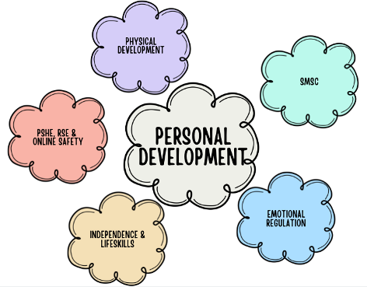
Encouraging regular, relaxed conversations around these questions can help your child feel supported, understood, and more confident in managing their digital wellbeing.

