The Importance of Personal Development
Personal development helps young people understand themselves, manage challenges, and build the emotional skills they need for school, relationships, and adult life. During the teenage years, students experience rapid changes in their brains, bodies, and social worlds. Learning how to recognise emotions, cope with stress and develop healthy habits supports mental wellbeing, builds resilience, and helps students feel more confident and in control. When parents and carers talk openly about these topics at home, it reinforces learning and shows young people that their wellbeing really matters
Curriculum Topic Overview – Year 7 Summer Half Term 2
Healthy & Balanced Lifestyles
Students explore what it means to live a healthy lifestyle, including the importance of balance across physical health, mental wellbeing, and daily habits.
The Balanced Diet
This topic focuses on nutrition, helping students understand the key food groups, the importance of a balanced diet, and how food choices impact energy, growth, and overall health.
Healthy Eating, Healthy Living
Students build on their understanding of nutrition by exploring how healthy eating habits contribute to long-term wellbeing and how to make informed choices in everyday life.
Sleep Essentials
Students learn why sleep is important for physical health, emotional wellbeing, concentration, and learning, as well as how much sleep they need during adolescence.
Phones and Sleep
This area explores the impact of screen time on sleep quality, including how phones and devices can affect sleep patterns and practical ways to improve sleep habits.
Investing in Your Health
Students consider how the choices they make now can affect their future health, encouraging responsibility, self-care, and long-term thinking about wellbeing.
Deepfakes and AI
Students are introduced to digital awareness, including understanding what deepfakes and artificial intelligence are, how they are used, and how to think critically about online content and misinformation.

Reflection Questions You Can Discuss at Home
- What does a healthy and balanced lifestyle look like to you? What small changes could improve your daily routine?
- Why is it important to eat a balanced diet? How do different foods affect your energy and mood?
- How much sleep do you think you need, and how does your sleep affect how you feel during the day?
- How do phones or screens impact your sleep? What could help you switch off before bedtime?
- What does “investing in your health” mean for your future? What habits could you start building now?
- What are deepfakes and AI? Why is it important to question what we see online? How can we stay safe and informed?
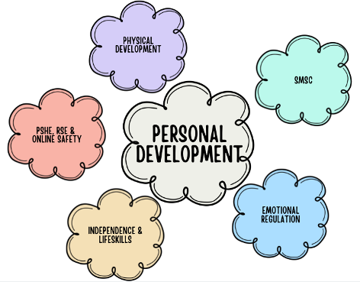
Encouraging regular, relaxed conversations around these questions can help your child feel supported, understood, and more confident in managing their digital wellbeing.

