The Importance of Personal Development
Personal development helps young people understand themselves, manage challenges, and build the emotional skills they need for school, relationships, and adult life. During the teenage years, students experience rapid changes in their brains, bodies, and social worlds. Learning how to recognise emotions, cope with stress and develop healthy habits supports mental wellbeing, builds resilience, and helps students feel more confident and in control. When parents and carers talk openly about these topics at home, it reinforces learning and shows young people that their wellbeing really matters
Curriculum Topic Overview – Year 8 Spring Half Term 2
First Aid Beyond Emergencies
Students learn essential first aid skills that go beyond basic emergencies, including how to respond to minor injuries, recognise signs of serious conditions, and support peers safely until professional help arrives.
Oral Hygiene
This topic covers the importance of daily oral care, the role of diet and lifestyle in dental health, and techniques for maintaining healthy teeth and gums.
Health & Hygiene
Students explore personal hygiene practices, the connection between cleanliness and overall health, and habits that reduce the spread of infections and illness.
The Mind-Body Connection
This area examines how mental wellbeing affects physical health, strategies for stress management, and the benefits of mindfulness, exercise, and balanced routines.
Drug Awareness
Students learn about the effects of various drugs, the risks of misuse, and strategies for making informed decisions and resisting peer pressure.
Alcohol and Social Inhibitions
This topic focuses on understanding how alcohol can affect behaviour, decision-making, and social interactions, as well as strategies for handling peer influence and making safe choices.

Reflection Questions you can discuss at home
When someone gets hurt or sick, how do you usually respond, and what first aid skills could help you feel more confident in those situations?
What daily habits do you have for keeping your teeth and mouth healthy, and are there areas you could improve?
How do you take care of your personal hygiene, and what small changes could make a big difference to your health?
How do your thoughts, feelings, or stress levels affect your body, sleep, or energy, and what strategies help you stay balanced?
What have you learned about drugs or alcohol that could help you make safe, informed choices in real-life situations?
How do you handle peer pressure when friends are experimenting with alcohol or other substances, and what support or strategies help you stick to your choices?

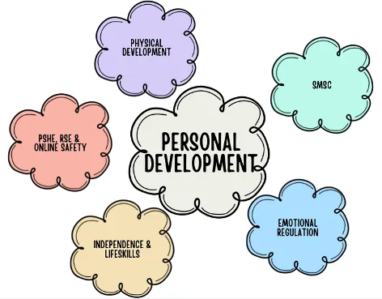
Encouraging regular, relaxed conversations around these questions can help your child feel supported, understood, and more confident in managing their health and wellbeing.

