The Importance of Personal Development
Personal development helps young people understand themselves, manage challenges, and build the emotional skills they need for school, relationships, and adult life. During the teenage years, students experience rapid changes in their brains, bodies, and social worlds. Learning how to recognise emotions, cope with stress and develop healthy habits supports mental wellbeing, builds resilience, and helps students feel more confident and in control. When parents and carers talk openly about these topics at home, it reinforces learning and shows young people that their wellbeing really matters
Curriculum Topic Overview – Year 8 Summer Half Term 2
Overcoming Limiting Beliefs
Students explore how negative or limiting beliefs about themselves can hold them back. They learn strategies to challenge unhelpful thoughts and build a more positive and confident mindset.
Optimising Character Strengths
This topic helps students identify their personal strengths and understand how to use them effectively in different areas of their lives, including school, friendships, and personal goals.
Strengths-Based Thinking
Students develop the ability to focus on what they do well rather than what they find difficult, encouraging a growth mindset and improved self-esteem.
Taking Control with Worry Time
Students are introduced to practical techniques for managing worry, including setting aside specific “worry time” to help reduce overthinking and improve focus.
Changing Emotions
This area focuses on understanding emotions and learning strategies to manage and regulate them in healthy ways, particularly during challenging situations.
Drug Laws UK
Students gain an understanding of the legal framework around drugs in the UK, including the classification system, risks, and consequences of drug misuse.
Real Life Resilience
Students explore what resilience looks like in real life, learning how to cope with setbacks, adapt to challenges, and build perseverance.

Reflection Questions You Can Discuss at Home
- Have you ever had a thought that made you feel like you couldn’t do something? How could you challenge that belief?
- What do you think your biggest strengths are? How can you use them more in your daily life?
- Why is it helpful to focus on your strengths instead of your weaknesses?
- What do you usually worry about? How might setting aside “worry time” help you manage those thoughts?
- How do you deal with strong emotions? What strategies help you calm down or feel better?
- Why is it important to understand drug laws and the risks involved?
- What does resilience mean to you? Can you think of a time you showed resilience?
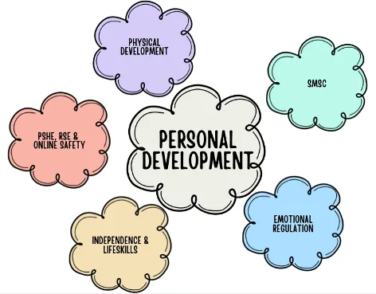
Encouraging regular, relaxed conversations around these questions can help your child feel supported, understood, and more confident in managing their health and wellbeing.

