The Importance of Personal Development
Personal development helps young people understand themselves, manage challenges, and build the emotional skills they need for school, relationships, and adult life. During the teenage years, students experience rapid changes in their brains, bodies, and social worlds. Learning how to recognise emotions, cope with stress and develop healthy habits supports mental wellbeing, builds resilience, and helps students feel more confident and in control. When parents and carers talk openly about these topics at home, it reinforces learning and shows young people that their wellbeing really matters

The Importance of Relationships and Reproductive Health Education
Learning about sexual health and reproductive choices helps young people make informed, responsible, and safe decisions as they grow. During adolescence, students experience physical, emotional, and social changes, and it is essential they receive accurate, respectful and age-appropriate information. Understanding healthy relationships, consent, sexual health, and personal choices supports wellbeing, confidence, and personal safety.

Curriculum Topic Overview – Year 9 Spring Half Term 1

Safe & Healthy Sex
Students learn about healthy relationships, consent, boundaries, and personal responsibility. The focus is on understanding respect, communication, and the importance of making safe choices.

Sexually Transmitted Infections (STIs)
This topic introduces what STIs are, how they can be transmitted and why prevention and early treatment are important. Students learn how to protect themselves and others, and where to seek reliable help and advice.

Reproductive Health
Students explore how the reproductive system works and how physical changes occur during puberty. This topic aims to build understanding, reduce embarrassment, and encourage positive attitudes towards health and wellbeing.

Pregnancy Choices
Students learn about pregnancy, including the different options available and the importance of informed, non-judgemental decision-making. The focus is on understanding support, responsibility, and respect for individual choices.

Forced Marriages
This topic helps students understand what forced marriage is and how it differs from arranged marriage. Students learn about personal rights, consent and where to seek help if they or someone they know may be at risk.
- Why is communication and consent important in healthy relationships?

- What steps can people take to protect their sexual health and wellbeing?

- Why is it important to understand how the body changes during adolescence?

- What support might someone need when facing a difficult or life-changing decision?

- Why is it important that marriage and relationships are based on choice and consent?
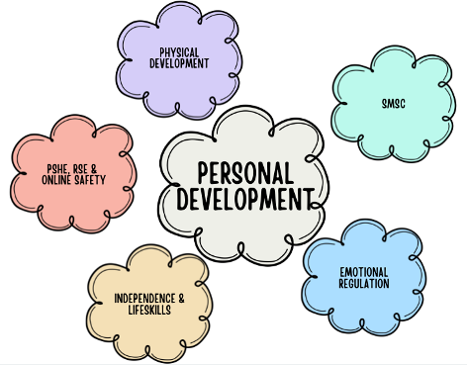
Encouraging respectful, age-appropriate conversations around these topics can help your child feel informed, safe and confident in understanding relationships, health and personal rights.

