The Importance of Personal Development
Personal development helps young people understand themselves, manage challenges, and build the emotional skills they need for school, relationships, and adult life. During the teenage years, students experience rapid changes in their brains, bodies, and social worlds. Learning how to recognise emotions, cope with stress and develop healthy habits supports mental wellbeing, builds resilience, and helps students feel more confident and in control. When parents and carers talk openly about these topics at home, it reinforces learning and shows young people that their wellbeing really matters
Curriculum Topic Overview – Year 9 Spring Half Term 2
Volunteering in My Community
Students explore ways to get involved in their local community, understand the benefits of volunteering, and reflect on how helping others can make a positive difference.
How Laws Are Made
This topic introduces students to the process of creating laws, the role of government and parliament, and how laws impact everyday life.
Budgeting and Long-Term Goals
Students learn how to manage money, plan for future needs, and set achievable financial goals, including distinguishing between wants and needs.
Introduction to Investment
This area covers the basics of investing, including how savings can grow over time, different types of investments, and the importance of making informed financial choices.
Financial Risk
Students explore the concept of risk in finance, how to evaluate potential outcomes, and strategies for making safe decisions with money.
Fraud and Theft
This topic examines the dangers of financial scams, identity theft, and fraud, and provides guidance on how to protect personal information and report suspicious activity.

Reflection Questions you can discuss at home
What motivates you to help others in your community, and how could volunteering make a difference for yourself and others?
How do you think laws affect your daily life, and why is it important to understand how they are made?
How do you decide what to spend your money on, and what strategies could help you stick to a budget and reach your long-term goals?
What do you know about investing, and how could making informed choices with money help you in the future?
How do you weigh the risks and benefits before making financial decisions, and what strategies help you manage potential losses?
Have you ever encountered scams or suspicious offers, and what steps could you take to protect yourself from fraud or theft?

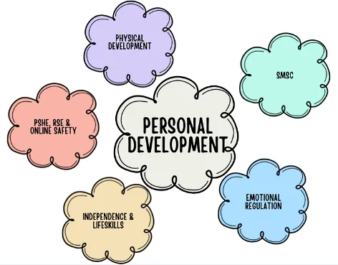
Encouraging regular, relaxed conversations around these questions can help your child feel supported, understood, and more confident in managing their health and wellbeing.

